5. Methodological Deviations
[PENDING: working title and structure. The reviewer asked that Chapter 5 report what was modified and what is new, and that Chapter 6 report the results. This chapter is written from the deviations log (Appendix C, D-1 to D-40). The labels Modified and New in the tables are the drafter’s reading of each entry and have to be confirmed by the team against the approved proposal. Four entries still carry an open item in Appendix C: D-13 (hardware test of the fsync change), D-14 (full-run and sniffer validation at 20 MHz), D-19 (exact Yuchengco area) and D-28 (adviser to confirm the star wormhole). Chapters 1 to 4 and the appendices still refer to the results chapter as Chapter 5, and every such reference has to be renumbered to Chapter 6.]
This chapter states what was changed from the approved proposal and what was added to it. The results that follow from these changes are reported in Chapter 6. Each change carries its identifier from Appendix C (D-1 to D-40), where the full entry is kept. A change is labelled Modified when it replaces something that the proposal specified, and New when it adds a rule, a procedure or a data item that the proposal did not contain.

5.1. Overview of the Changes
The 40 entries fall into five groups (Table 5.1): data collection and sampling, feature definitions, the implementation of the attacks, the experimental design, and run control and validation. Three reasons recur in Appendix C. The first is that a planned measure could not be taken on the ESP32 platform as planned, as with the MAC retry count (D-15) or the round-trip time (D-2 and D-3). The second is that the planned design would not have produced the intended attack or would have exposed the label, as with the relay feature that existed on the attacker alone (D-12) and the wormhole ends at the same depth (D-17). The third is that a check or a gate was needed to make a run a valid experiment, as with the pre-run gates (D-22) and the grading of missing boards (D-32).
Table 5.1 Groups of Changes and Where Their Effect Is Reported
Group | Entries | Main change | Reported in
Data collection and sampling | D-1, D-9, D-13, D-14, D-25 | Boards log at 10 Hz and the analysis uses one-second windows of ten samples (the proposal had five-second windows of five samples). The radio is fixed at 20 MHz. | Section 6.1, Table 6.1
Feature definitions | D-2, D-3, D-7, D-8, D-10, D-11, D-15 | Latency is one-way, not a round trip. The retry rate comes from application counters, not from the MAC layer. Run identifiers are columns on every row. | Section 6.1 (Table 6.4), Section 6.2.4
Implementation of the attacks | D-12, D-16, D-17, D-20, D-28, D-30, D-36, D-39 | Both attacks are emulated at the application layer, and every node relays probes hop by hop so that forwarding can be counted. The wormhole ends join the mesh as leaf nodes, and in the tree they scan the mesh channel only. | Sections 6.2.1 and 6.5.3
Experimental design | D-5, D-6, D-18, D-19, D-26, D-29, D-33, D-35, D-37, D-38, D-40 | The baseline is phase 0 of each attack run, and 8 matched benign runs are added, which gives 80 runs. Runs are made at three sites with three scenarios, and the tree builds have their own rules for parents. | Sections 6.1 and 6.5.4
Run control and validation | D-4, D-21, D-22, D-23, D-24, D-27, D-31, D-32, D-34 | A run starts only after pre-run gates are met, and the verifier grades each run, including runs with a missing board and runs whose scenario was not applied. | Tables 6.2, 6.3 and 6.5[1]

Legend:
● Entries = the identifiers of Table C.1 in Appendix C; D-n stands for deviation number n from the approved proposal. The tables of Sections 5.2 to 5.6 list the entries of each group.
● Hz = hertz, samples per second; 10 Hz = one sample every 0.1 s.
● Window = one second of recording from one board, with up to ten samples.
● MHz = million hertz; here the width of the Wi-Fi channel that the radio uses.
● Latency = the time a probe takes to travel from its sender to the root; one-way = measured in the direction of the root only; round trip = there and back.
● MAC layer = the Wi-Fi layer that controls access to the radio channel and retransmits frames that were lost; retry rate = the share of send attempts that failed in a window.
● Application layer = the software of the study that runs on each board, above the mesh stack; application counters = the counts that this software keeps.
● Run identifiers = the columns that name the attack, topology, site, scenario and repeat of a run.
● Relay = to receive a probe and send it on one hop towards the root; the forwarding of a node is counted from this.
● Baseline (phase 0) = the first 300 s of an attack run, before the attack starts.
● Benign run = a run with no attack; matched = set up like an attack run, so that it can be compared with the attack runs.
● Pre-run gates = the checks that the root makes before the timed phases of a run can start, for example that every child has joined.
● Verifier = the script that checks every run against its schedule (Section 4.2.7.1).
Chapters 5 and 6 cite each change by its identifier, in the form D-20. D stands for deviation from the approved proposal. Table 5.2 lists all 40 identifiers in numerical order with the topic name used in Appendix C, what the change means in one line, and the table of this chapter that gives the entry in full.[2]
Table 5.2 Index of the Deviation Identifiers D-1 to D-40
ID | Topic | In plain words | Given in full in
D-1 | Sampling rate | Each board records 10 samples per second, so a one-second window holds ten samples. | Table 5.3
D-2 | LatencyHopRatio | Latency is the one-way delay of a probe per hop, not a round-trip time. | Table 5.4
D-3 | TunnelLatency | Tunnel latency is the gap in arrival time between a probe and its tunnelled copy at the root. | Table 5.4
D-4 | Topology check | Parent changes in the first 60 s count as the mesh forming, not as re-routing. | Table 5.7
D-5 | Baseline control | The first 300 s of every attack run serve as the baseline. | Table 5.6
D-6 | Repeats and parents | The topology type is fixed for a run, but which board sits where is left to the mesh. | Table 5.6
D-7 | run_repeat column | Every row records which repeat of a run it belongs to. | Table 5.4
D-8 | PDR attribution | A window gets a delivery ratio, even 0, when the node sent in it and the root’s log covers it. | Table 5.4
D-9 | Grid and window | The data are cut into one-second windows, and a window needs at least 8 of its 10 samples. | Table 5.3
D-10 | Run columns | Every row records the attack, topology, site and scenario of its run. | Table 5.4
D-11 | Hop, not layer | The feature counts hop changes, where hop = mesh layer − 1. | Table 5.4
D-12 | Application-layer relay | Every node forwards probes itself at the application layer, so that forwarding can be counted. | Table 5.5
D-13 | microSD mirror | The memory-card copy of the log is forced to be written to the card. | Table 5.3
D-14 | Radio width | The Wi-Fi channel is fixed at 20 MHz and recorded in every capture. | Table 5.3
D-15 | Application counters | Retry counts come from the software on the boards, not from the Wi-Fi hardware. | Table 5.4
D-16 | Star and blackhole | In the star topology the attacker is the hub and the root sits behind it. | Table 5.5
D-17 | Wormhole ends | The two ends of the wormhole tunnel are chosen at run time from mesh depth and then locked. | Table 5.5
D-18 | Matched benign runs | Benign runs without any attack are added as a matched control; the final plan has 8. | Table 5.6
D-19 | Sites | Runs are made at three sites: G402, the DLSU Library and the Yuchengco Building. | Table 5.6
D-20 | Attack emulation | Both attacks act on the study’s own probes at the application layer, not on the routing. | Table 5.5
D-21 | Wormhole verification | The wormhole is verified by two independent measures, one from the attackers and one from the root. | Table 5.7
D-22 | Pre-run gates and START | A run starts only when the setup checks pass and the operator types START. | Table 5.7
D-23 | Parent changes in the attack | A board may change parent during the attack if it stays a victim or stays a bystander. | Table 5.7
D-24 | START lock | A failed check blocks START unless a reason is typed and logged. | Table 5.7
D-25 | Tick alignment | Each sample takes the earliest free time slot, at most 300 ms late. | Table 5.3
D-26 | Sticky tree parents | In tree runs the boards switch parent less readily. | Table 5.6
D-27 | Topology gate | A board passes the topology check if it is attached at the start of the baseline and does not re-route. | Table 5.7
D-28 | Star wormhole | In the star the exit end of the wormhole is the hub. | Table 5.5
D-29 | Partial mesh | The partial mesh is defined by placement and at most two children per node. | Table 5.6
D-30 | Wormhole end depth | In tree and partial-mesh wormhole runs the entry end sits deeper than the exit end. | Table 5.5
D-31 | Attacker re-parenting | The attacker may change its own parent only if no board changes class and its uplink is down at most 10% of the attack. | Table 5.7
D-32 | Missing boards | A missing board is graded by its role, and not by a plain board count. | Table 5.7
D-33 | Jitter scenario | The jitter scenario is left out of the plan, which leaves three scenarios. | Table 5.6
D-34 | Scenario not applied | A run whose scenario was not applied is graded as minor gaps. | Table 5.7
D-35 | Benign run plan | The benign runs are spread over the sites and the scenarios; 8 remain in the final plan. | Table 5.6
D-36 | Wormhole ends as leaves | In the tree and the partial mesh, the wormhole ends join as leaf nodes. | Table 5.5
D-37 | Tree fan-out cap | Tree boards were limited to two children, and wormhole end B was given a fallback parent. | Table 5.6
D-38 | Tree association time | In the tree, a parent keeps a silent child for 30 s instead of 10 s. | Table 5.6
D-39 | Wormhole end scan | In the tree, the wormhole ends scan the mesh channel only. | Table 5.5
D-40 | Tree fan-out restored | The tree fan-out returns to the stock limit of 10 children. | Table 5.6

Legend:
● Topic = the name used in Table C.1 of Appendix C. Given in full in = the table of this chapter that gives the entry in full and shows whether it is Modified or New.
● D-n = deviation number n from the approved proposal; the full entry is in Table C.1 of Appendix C.
● Kind: Modified = replaces what the proposal specified; New = added to the proposal.
● Window = one second of recording from one board, with up to ten samples.
● Hz = hertz, samples per second; 10 Hz = one sample every 0.1 s.
● Tick = one slot of the 10 Hz sampling grid (0.1 s).
● Probe = the small packet that a node sends towards the root about once a second to measure delivery.
● Root = the board that receives every probe and logs the arrivals (one in each run).
● Hop = one wireless link on the path to the root.
● Mesh layer = the depth of a board in the mesh tree, with the root as layer 1; hop = layer − 1.
● PDR = packet delivery ratio, the share of a node’s probes that reached the root (ratio, 0 to 1).
● LatencyHopRatio = the relative one-way delay of a probe divided by its hop count; TunnelLatency = the difference in arrival delay between the two copies of one probe at the root.
● run_repeat = the column that gives the number of the repeat of a run; HopChangeCount = the number of changes of the hop of a board in a window.
● Topology = the shape in which the boards are linked to the root: linear (a chain), star, tree or partial mesh.
● Wormhole = the emulated tunnel in which a probe is also copied over a wired link from the entry end (Node B) to the exit end (Node A).
● Hub = the board in the centre of the star, through which every other board reaches the root.
● Application layer = the software of the study that runs on each board, above the mesh stack; application counters = the counts that this software keeps.
● microSD mirror = the copy of the log that each board writes to a memory card.
● START = the operator’s command that begins the timed phases of a run.
● Pre-run gates = the checks that the root makes before the timed phases of a run can start, for example that every child has joined.
● Verifier = the script that checks every run against its schedule (Section 4.2.7.1).
The 40 entries of Appendix C were not planned at the start of the study. They were made between July and October 2026, each time that a capture or a review showed that the approved plan could not be followed as written, or that following it would yield data that could not be trusted. The earliest entries arose from the first captures of July (D-1, D-2, D-3 and D-4), several from the work of September (D-8, D-11, D-14 and D-15), and the last from the October campaign, in which failed runs and reviews were turned into rules so that the same failure could not recur, and in which the plan itself was adjusted (D-21 to D-40, 16 to 23 October 2026). For each entry, Appendix C records what the proposal said, what is done instead, why, and what the change costs.
Three reasons recur. The first is that a planned quantity could not be measured on the platform: a round-trip time requires a reply that the probes never receive (D-2 and D-3), and ESP-IDF provides no MAC retry count (D-15). The second is that the planned design would have allowed the label to be read from the data without any learning, or would not have produced the intended attack: a relay feature that exists on the attacker alone identifies the attacker (D-12), a wormhole whose two ends lie at the same depth has no shortcut (D-17, D-28 and D-30), and the ends of a wormhole in a tree or a partial mesh did not join the mesh in a way that gave a valid run (D-36 to D-40). The third is that a run must constitute one valid experiment, whereas a mesh heals itself, boards reset and cards fail, so that rules had to be written for when a run may start and for what a run may contain (D-4, D-21 to D-32 and D-34). Some entries record a decision on the scope of the study and not a problem of the platform, for example the choice of sites (D-19), of benign runs (D-18 and D-35) and of scenarios (D-33). Of the 40 entries, 15 are labelled Modified and 25 New in the tables of this chapter.
Sections 5.2 to 5.6 take the five groups of Table 5.1 in turn. Each begins with a table that states, for every entry, what the study does and why, and continues with a narration that treats the entries of the group one by one. The narration supplies what the table cannot: what the proposal specified, what happened in the captures, how the change works, the evidence that it worked, and what it costs. Section 5.7 states which of the changes limit how the results of Chapter 6 can be read.
[PENDING, internal note to delete before submission: Appendix C also holds D-41 (23 October 2026), which the log marks as not for the paper. For tree wormhole runs only, it applies the mesh logic of the partial mesh (a limit of two children, an association expiry of 10 s, no sticky parents, B as the strongest open parent at least as deep as A, and a scan of all channels) and keeps the leaf ends of D-36. For those runs it therefore replaces what D-26, D-38, D-39 and D-40 say about the tree and brings back the limit of D-37. This chapter follows the log and does not describe D-41, so it counts D-1 to D-40. Decide whether the tree wormhole runs captured after D-41 need a note, because the rules described here would not apply to them.]
[PENDING: D-33 to D-40 are written as the log records them. D-36 to D-40 were compile-checked and not yet tested on hardware when they were entered, and tree wormhole captures of 23 and 24 October followed, so confirm their status. D-40 withdraws the sentence on at most two children in the tree that D-37 proposed for the paper (checklist A38). D-33, D-35, D-36 and D-37 are marked in the log for the adviser’s check. Confirm that Appendix C lists D-33 to D-40, and confirm the labels of these eight entries, which are the drafter’s reading (D-33 Modified, the others New).]

5.2. Data Collection and Sampling
The proposal planned five-second windows of five samples. The first captures showed that this left no room for a dropped sample, so the sampling rate, the grid and the window were changed (D-1, D-9, D-25), and two protections of the data were added (D-13, D-14).[3]
Table 5.3 Changes to Data Collection and Sampling
ID and topic | Kind | What the study does | Why
D-1 Sampling rate | Modified | The boards log at 10 Hz, and the analysis keeps the 10 Hz samples (see D-9). | Five samples per window left no room for a dropped sample.
D-9 Grid and window | Modified | A 10 Hz grid and one-second windows are used; a window with fewer than 8 of 10 samples is discarded. | The 80% completeness ratio is kept, with more support per row.
D-25 Tick alignment | New | Each sample takes the earliest free tick, at most 300 ms late. | Placement on the nearest tick discarded healthy windows.
D-13 microSD mirror | New | The microSD mirror is flushed with fsync(). [PENDING: mid-run-reset test on hardware] | It fixes a failure in which a card file held 0 rows. It has not been validated on hardware.
D-14 Radio width | New | The radio is fixed at 20 MHz (HT20), and every capture records its width. [PENDING: full-run and sniffer validation] | The sniffer captures 20 MHz only, and the two widths differ in PHY behaviour.

Legend:
● Kind: Modified = replaces what the proposal specified; New = added to the proposal.
● Window = one second of recording from one board, with up to ten samples.
● Sample = one reading of a board (one telemetry row); the boards take 10 samples per second.
● Hz = hertz, samples per second; 10 Hz = one sample every 0.1 s.
● Tick = one slot of the 10 Hz sampling grid (0.1 s).
● Interpolation = filling a short gap with values computed from the samples on either side; forward fill = repeating the last value.
● Baseline run = a capture with no attack.
● microSD mirror = the copy of the log that each board writes to a memory card.
● fsync() = a call that forces the data in a file to be written to the card.
● Mesh formation = the time in which the boards join the mesh and choose their parents.
● HT20 = the 20 MHz Wi-Fi channel width; HT40 = the 40 MHz width, which is the default of the ESP32; MHz = million hertz.
● PHY = the physical layer of Wi-Fi, which sets the radio rates and the use of the channel.
● Sniffer = a separate radio that records the Wi-Fi frames.
Entries D-1 and D-9 concern the sampling rate and the analysis window. The proposal planned raw telemetry at 1 Hz and windows of five seconds, which gives five samples per window, with a window being discarded when fewer than 4 of its 5 samples are present. With so few samples, a single lost sample costs 20% of a window and can trigger the discard rule. The boards therefore sample at 10 Hz, one sample every 100 ms.
In its first form, the change (D-1) preserved the analysis rate of the proposal by reducing the data to 1 Hz before windowing, which discarded 9 of every 10 samples that had been captured. D-9 replaced that step: the data are analysed on the 10 Hz grid in windows of one second, as the panel and the adviser requested, and a window with fewer than 8 of its 10 samples is discarded, which is the same 80% completeness ratio as 4 of 5.
The number of rows provided a further reason. The panel asked for about 10,000 rows per run and the team had proposed 6,000, and the number of rows is determined by the number of nodes and by the analysed seconds divided by the window length. With five-second windows and the six nodes then in use, 6,000 rows would have required a run of about 83 minutes.
Each window now holds ten samples instead of five and therefore carries more support. Nothing is invented to reach this: gaps of one or two samples are filled, by interpolation or forward fill, which at 10 Hz covers 0.2 s where at 1 Hz it covered 2 s, so that less of the data is synthetic than before. On a clean baseline run, the change raised the number of rows from 577 to 2,894 (five times as many) and lowered the share of discarded windows from 1.0% (6 of 583 windows) to 0.1%.
One consequence must be kept in mind. A probe is sent about once a second, so a window of one second holds about one probe, and the delivery ratio of a single window is close to 0 or 1. The delivery ratio is therefore read through the mean over many windows and not as a fine-grained rate.
Entry D-25 concerns the alignment of the samples to the 0.1 s grid. The sampling task of the firmware runs on a fixed period. When the task is held up, it takes the missed samples back to back, so that the gaps between consecutive rows can be, for example, 258 ms, 1 ms and 41 ms. The first version of the analysis placed every sample on the nearest tick of the grid. Two samples that arrived in a burst therefore shared one tick and left an empty tick behind, and three empty ticks were sufficient to discard the window. Windows were consequently lost although no sample was missing on the card.
The rule is now that each sample takes the earliest free tick for which it could have been scheduled, at most 3 ticks (300 ms) late and never early. The lateness limit derives from the data, since the 99th percentile of the measured delay was 278 ms. There is one sample per tick, and nothing is invented, interpolated further or counted twice. The 80% rule and the filling of gaps of one or two samples remain as before. On two boards with clustered timestamps, FE90 and ED80, the share of discarded windows fell from 10% to 0% and from 15% to 0%, and boards that were already clean did not change. No verdict changed, but the grades of some runs became more accurate. The reason for the change is that the old rule measured the resampling and not the board, whereas a missing window should now correspond to a missing sample.
Entry D-13 concerns the microSD mirror of the log. Each board writes every telemetry row to its flash memory and mirrors it to a microSD card. Operators found that a file pulled from a card sometimes held no rows, with no pattern that could be identified, and the run had to be repeated. The cause lay in the logger, which flushed with fflush() alone. On the file system that ESP-IDF uses for the card, this pushes the bytes to the card but does not update the directory entry of the file, which holds its recorded size and is updated only by fsync() or by closing the file. A run that did not end cleanly, because of a brownout, a reset, a card pulled while the board was on, or a killed run, therefore left a file whose size still read 0 bytes although its rows were on the card, and every host tool counted it as empty. Clean runs were never affected, which is why the failure appeared random.
The logger now calls fsync() on the mirrored files at most every 5 s and at every phase boundary, so that the worst case falls from the whole run to the last few seconds. The change repairs nothing that was captured before it, and a file from before the change that holds 0 rows has to be treated as lost and not as a board that logged nothing. None of the 435 campus capture files has 0 rows. At import, the number of rows streamed is now compared with the number in the manifest of the run, and a difference is printed. The firmware compiles, but the change has not yet been tested on hardware, which requires a board, a reset in the middle of a run and a read-back of the card.
Entry D-14 concerns the width of the radio channel. The proposal does not state a channel width, so every capture made before 23 September 2026 used the ESP32 default of 40 MHz (HT40). The only independent observer available to the study, a sniffer, captures 20 MHz only, and a 20 MHz receiver cannot decode 40 MHz data frames. In a capture of 23 September it heard the beacons of every board but almost none of their data frames (0 for the root and 3 of 1,848 for a child). Without a change, the sniffer could not have served as the third-party check on the dataset.
The radio is now fixed at 20 MHz (HT20) on both of its interfaces before it starts. Every boot prints the width, and the status report of the card records it, so that every capture carries its own width. The order matters: a first version fixed the width after the radio had started, and no node joined the mesh in a full 11-minute run, whereas fixing it before the start resolved this.
Captures at 40 MHz differ in the PHY (the rates, the airtime and possibly the RSSI by a few dB). They are archived, labelled by width and never pooled unlabelled, and the dataset uses the captures at 20 MHz only. The verifier is not affected, because it compares phases within one run. Mesh formation at 20 MHz was verified on hardware on 24 September 2026 in a test of 3 minutes. A full run at 20 MHz and a sniffer capture of its data frames remain to be validated.

5.3. Features and Measurements
Several features were defined differently from the original planned implementation because the platform does not provide the quantity that was planned. Probes travel one way to the root, so latency is one-way (D-2, D-3), and ESP-IDF returns no MAC retry count, so the retry rate comes from application counters (D-15). Three entries add rules for when a feature has a value (D-8) and for naming and labelling (D-7, D-10, D-11).[4]
Table 5.4 Changes to Feature Definitions and Measurements
ID and topic | Kind | What the study does | Why
D-2 LatencyHopRatio | Modified | LatencyHopRatio is the relative one-way delay divided by the hop count (Equation 4.14). | Probes travel one way, so no round trip exists in the data.
D-3 TunnelLatency | Modified | TunnelLatency is the difference in arrival delay between the two copies of one probe. | The tunnel is a one-way UART write with no echo.
D-8 PDR attribution | New | A window gets a PDR, including 0, when the node sent, was associated and the root’s log covers it. | The old run-wide rule hid the zeros of the nodes most affected.
D-11 Hop, not layer | Modified | The feature is named HopChangeCount, and hop = layer − 1 is added next to the raw layer. | The old name suggested network-layer data.
D-15 Application counters | Modified | retry_count and tx_count are application counters, and RetryRate is not a model input. | ESP-IDF returns no MAC retry count.
D-7 run_repeat column | New | The repeat number is a column in the windowed and feature tables. | Pooled runs cannot be separated again, so per-repeat variance would be lost.
D-10 Run columns | New | Attack, topology, location and scenario are columns on every row. | Without them, runs of different scenarios collapsed into one group.

Legend:
● Kind: Modified = replaces what the proposal specified; New = added to the proposal.
● PDR = packet delivery ratio, the share of a node’s probes that reached the root (ratio, 0 to 1).
● UART = the wired serial link between the two tunnel boards.
● MAC = medium access control, the Wi-Fi layer that controls access to the radio channel and retransmits frames that were lost.
● Sniffer = a separate radio that records the Wi-Fi frames.
● LatencyHopRatio = the relative one-way delay of a probe divided by its hop count (Equation 4.14); relative = counted from the fastest delivery of the same sender in the run.
● TunnelLatency = the difference in arrival delay between the two copies of one probe at the root.
● One-way = the time to go to the root only; round trip = the time to go to the root and come back.
● Probe = the small packet that a node sends towards the root about once a second to measure delivery.
● Root = the board that receives every probe and logs the arrivals (one in each run).
● Hop = one wireless link on the path to the root.
● Mesh layer = the depth of a board in the mesh tree, with the root as layer 1; hop = layer − 1.
● HopChangeCount = the number of changes of the hop of a board in a window; RetryRate = the share of send attempts that failed in a window.
● Application counters = counts kept by the software of the study, here retry_count (failed sends; on Node B, frames sent into the tunnel) and tx_count (frames sent).
● Mesh association = the state in which a board holds a parent in the mesh.
● Network layer (IP) = the layer of the OSI model that carries IP addresses and routing; the mesh works below it.
● ESP-IDF = the software framework of Espressif, the maker of the ESP32.
● Windowed table = the table of one-second windows made by the preprocessing; feature table = the same windows with the features added.[5]
Entry D-2 concerns LatencyHopRatio. Equation 4.14 defines it as the mean round-trip time divided by the hop count, computed from probe-response exchanges between the victim nodes and the root. In the system that was built, a probe goes from a node to the root, and the root logs the arrival and sends nothing back, so no round trip exists in the data. The root does log a delay for every arrival, but it is the difference between the clock of the root and the clock of the sender, and each clock starts at the boot of its own board and is never synchronised with the other. The raw value is therefore the true one-way delay plus a large constant, which is strongly negative in practice because the children are powered before the root (−194 s on one wormhole run).
The constant is the same for all arrivals of one sender in one run, so subtracting the smallest delay of that sender cancels it and leaves the delay relative to the fastest delivery of that sender. LatencyHopRatio is this relative delay divided by the hop count. Each arrival is assigned to the window of the sender whose probe sequence numbers contain it, which is the same clock-free join that PDR uses. An earlier version joined on time, which mixed the two clocks and placed the latencies of the cooldown in attack windows; it was corrected on 26 September 2026.
On a baseline run of 25 July, the median was between 2.4 and 2.8 ms per hop at every depth from 1 to 5 hops. A flat ratio is what Equation 4.14 describes as normal forwarding. The range of 10 to 30 ms per hop that the proposal expected was an estimate for a round trip, and a one-way leg is about half of that, on boards that are faster than the estimate assumed. What the feature is for, namely detecting a delay that does not match the reported path length, is preserved, because it depends on the ratio varying and not on its size. Its limit is that the zero point belongs to each node and each run, so the values cannot be compared in absolute terms between nodes or runs. Only their shape can be compared, and the clustering of Chapter 6 uses standardised features.
Entry D-3 concerns TunnelLatency. The proposal defines it as the round-trip latency of the tunnel itself, measured with periodic echo messages. The tunnel between the two wormhole boards is a one-way write on a UART line, from Node B to Node A, and no echo frame is defined or sent, so there is no round trip to measure. What does exist is the signature of a wormhole: the same probe reaches the root twice, once by the multi-hop path and once through the tunnel, with a measurable difference in delay. The root does not remove the duplicate, so both arrivals reach the log.
TunnelLatency is therefore the largest minus the smallest delay among the arrivals of one probe (one sender and one sequence number). The two copies share one sender clock and one root clock, so the offset of D-2 cancels exactly, and the value is a measurement and not an estimate. On a linear wormhole run of 20 July there were 541 pairs of duplicates with a median difference of 12.2 ms and a range of 1.2 to 242 ms, and 102 of the 109 rows that have a value fall in the attack window.
The proposal gives the tunnel fields to the attacker nodes only. TunnelLatency is instead assigned to the sender whose probes were duplicated, as PDR is, because the difference belongs to the manipulated traffic and because the arrival log does not mark which copy came through the tunnel. TunnelIntensity and TunnelBytes remain with the attacker as specified. For the same reason, the difference has no sign: it does not indicate whether the tunnel was the faster path.
Entry D-8 concerns the attribution of PDR (Equation 4.5), which joins what each node sent with what the root logged. In the first code, a window could have a PDR only if the root had logged something from that node somewhere in the run. A node that the root never heard from therefore received no PDR in any window, and this is the node that a blackhole affects most severely. On a linear blackhole capture of 16 September 2026, three of the four victims sent in nearly every window and were treated as having no data, so that PDR = 0 appeared in none of the 446 rows. The feature that exists to detect the suppression of forwarding could not record the value it exists to detect.
A window now receives a PDR, including 0, when three conditions hold. First, the node sent in the window, because a ratio of 0 over 0 is undefined. Second, the node held a mesh association (a layer above 0 and a parent address that is not empty), because the undelivered probes of a detached node show lost connectivity and not suppressed forwarding. Third, the window lies inside the span in which the root was logging arrivals, which still prevents a missing root file from being read as a failure of delivery.
The first code also divided by the sum of 0 and a small constant, so that a window in which a node sent nothing came out as 0.0, the same as total failure, and a false blackhole signature could arise in this way. Such windows are now missing values. On that capture, the windows with a PDR rose from 41 to 238 of 446 and the windows with PDR = 0 from none to 201, and the PDR of the victims in the three phases read 0.217, 0.000 and 0.750, which is the expected shape of suppression and recovery. The definition of PDR is unchanged. Only the rule for when a window can be judged changed, and it is conservative in both directions, because it stops hiding real zeros and stops inventing false ones.
Entry D-11 concerns the naming of the hop count. ESP-WIFI-MESH numbers the depth of a node in its tree as a layer, with the root as layer 1, so that a direct child of the root is layer 2. Reviewers read the column name as an OSI layer. It is not, because the mesh runs entirely below IP and the dataset holds no network-layer data, and each time the name is misread, the reader believes that the cross-layer claim is larger than it is. The adviser asked for the change and a second reviewer asked for it independently (21 September 2026), so the problem lay in the name and not in the reader.
A new column hop = layer − 1 is added next to the raw layer, which is kept for traceability to what the firmware reported, and LayerChangeCount is renamed HopChangeCount. The offset of one is essential: a direct child is one hop from the root and the root is 0 hops from itself, and a rename that kept the values would have made every hop count wrong by one. The no-parent value of the firmware (layer = −1) becomes a missing hop value. HopChangeCount counts changes in depth, which a constant offset does not alter, so no feature value changed, and the pipeline gave identical values under the new name.
Entry D-15 concerns the application counters. The proposal takes retry_count, the cumulative MAC-layer retransmissions, and tx_count, the cumulative frames transmitted, from the Wi-Fi statistics of ESP-IDF. It also gives a fallback for a version that does not expose them: record zero, flag it in the metadata, leave RetryRate out of the core set, and use an application-layer proxy if wanted. The firmware reads no driver statistics. This was checked on 27 September 2026: the only statistics call in ESP-IDF 5.3.5 and in the documentation of version 5.5, esp_wifi_statis_dump(), prints the statistics to the log and returns only a status, so no number reaches the application, and no change to the firmware could put a MAC retry count into the data.
Both columns are therefore filled with application counters. On every role except the wormhole entry node B, retry_count is the number of failed esp_mesh_send() calls, that is, sends that the mesh stack refused, and not radio retransmissions. On Node B it holds the number of frames sent into the tunnel, because the tunnel features read it from there. The columns are not zero and are not flagged in the metadata, so this departs from the fallback of the proposal, and the MAC layer of the cross-layer claim rests on the RSSI and on the state of the link and the parent, and not on retransmissions.
RetryRate remains a column of the dataset. It is not a model input, as the fallback prescribes, and since 30 September 2026 the verifier no longer uses it as a check, because none of the attack studies cited (Airehrour et al. [70], Zhukabayeva et al. [71], Ramírez Gómez et al. [72]) names a retry rate as a signature. The predicted rise in the retransmissions of the victims (Table 3.4) cannot be seen with these counters. A blackhole that drops at the application layer still acknowledges every frame, so the radio of the victim never sees a failure; the prediction is reported in Section 6.2.4 as predicted and not observed, and not as missing data.
Real retries come from the sniffer: a retransmitted 802.11 frame carries the retry bit, and counting it per link and per phase gives the retry rate of an independent observer. Where a sniffer capture exists, the pipeline can add its retry rate and the number of frames it heard (MacRetryRate and MacFramesHeard) to the feature table, and a run without a capture remains a missing value and never 0.
Entries D-7 and D-10 concern the columns that identify a run. One analysis folder holds all repeats of a cell, and the preprocessing reads the whole folder, so the windows of the three repeats, and of the different scenarios, landed in one table with nothing to tell them apart. The script that gathered the folders re-derived the cell from the folder path and ignored the scenario, so a run with mobility and a run with no variation, of the same attack, topology and site, collapsed into one group. Runs can always be pooled but can never be separated again.
The preprocessing now writes run_repeat, taken from the file name, and attack, topology, location and scenario, taken from the path of the export, as columns on every windowed row, and they pass unchanged into the feature table. A run with no scenario folder is read as stationary, and a path that is not an export tree receives no value, so that an unknown origin is never labelled as if it were known. These columns are identifiers: no feature value, count of windows or label changed. They make every row self-describing, which the dataset needs in order to be reused, and they allow Chapter 6 to report results by topology, site and scenario.

5.4. Implementation of the Attacks
Both attacks are application-layer emulations (D-20). The mesh stack relays packets by itself and documents no way to write a node’s routing table, so the attacks act on the probes that the study sends and not on the routes. To make forwarding visible, every node relays probes at the application layer (D-12). The remaining entries fix where the attacker and the wormhole ends sit in each topology (D-16, D-17, D-28, D-30) and how the ends join the mesh (D-36, D-39).
Table 5.5 Changes to the Implementation of the Attacks
ID and topic | Kind | What the study does | Why
[6] D-12 Application-layer relay | Modified | Every node relays at the application layer and counts packets received, forwarded and dropped. | The relay features existed only on the attacker.
[7] D-20 Attack emulation | Modified | Both attacks act on the data plane only, and no route or parent selection is changed. | ESP-WIFI-MESH documents no way to write a routing table.
[8] D-16 Star and blackhole | Modified | In the star, the attacker is the hub and the root sits one hop behind it. | The root cannot drop instead of forward, and it is the referee.
[9] D-17 Wormhole ends | New | The wormhole ends are assigned at run time from mesh depth, locked at the first phase and recorded in every row. | The mesh decides which board is near the root, and a fixed assignment can give no shortcut.
[10] D-30 Wormhole end depth | New | In tree and partial-mesh builds, Node B never joins the root and stays deeper than Node A. | Both ends kept landing at the same depth.
[11] D-28 Star wormhole | New | In the star, wormhole end A is the hub and the root sits one hop behind it. | In a flat star, the tunnel skips no hop.
D-36 Wormhole ends as leaves | New | In tree and partial-mesh builds, the wormhole ends join as leaf nodes, and the telemetry stack is 6144 bytes. | Boards under an end moved whenever the end restarted, and the telemetry stack ran low.
D-39 Wormhole end scan | New | In tree builds, the wormhole ends scan the mesh channel only when they look for a parent. | A scan of all channels made a connected end miss the beacons of its parent.
[12]
Legend:
● Kind: Modified = replaces what the proposal specified; New = added to the proposal.
● Hub = the board in the centre of the star, through which every other board reaches the root.
● Hop = one wireless link on the path to the root.
● Wormhole = the emulated tunnel in which a probe is also copied over a wired link from the entry end (Node B) to the exit end (Node A).
● Node A = the exit end of the wormhole, on the root side; Node B = the entry end, on the leaf side.
● Star = every other board is linked to one central board, the hub; tree = boards branch from the root over several hops; partial mesh = a branched tree in which a board can hear several candidate parents and has at most two children (Section 5.5).
● Blackhole = the emulated attack in which a board that relays probes silently drops them; the attacker is that board.
● Relay = to receive a probe and send it on one hop towards the root; the forwarding of a node is counted from this.
● Application layer = the software of the study that runs on each board, above the mesh stack; application counters = the counts that this software keeps.
● Referee = the root, which drives the phases and logs the arrivals from which PDR is measured.
● Routing = the choice of the path that a packet takes; parent selection = the way in which a board chooses the board it sends to.
● Shortcut = a path to the root with fewer hops than the normal path.
● Mesh depth = the layer of a board in the mesh tree; locked = a role that is fixed at the first phase and does not change for the rest of the run.
● UART = the wired serial link between the two tunnel boards.
● Baseline (phase 0) = the first 300 s of an attack run, before the attack starts.
● Verifier = the script that checks every run against its schedule (Section 4.2.7.1).
● Leaf node = a board that forwards no traffic for other boards, so that no board can attach below it; child = a board that attaches below another board.
● Telemetry task = the task on each board that reports its state to the root; stack = the memory reserved for a task; backtrace = the record of the calls that led to a restart.
● Layout = which board sits at which place in the mesh; recapture = to run the capture again.
● Scan = the search of a board for access points to join as parent; passive = the board only listens; beacon = the frame by which an access point announces itself; mesh channel = the Wi-Fi channel of the mesh (channel 11).
Entry D-20 concerns the way in which the attacks are emulated. In the studies that the thesis cites, a blackhole advertises a false short route to attract traffic and then drops it, and the tunnel of a wormhole causes the routing protocol to adopt a false shortcut, so that distant nodes appear to be neighbours. Both attacks therefore act on the control plane. This study implements only the behaviour on the data plane, on real hardware. The blackhole is a legitimate mesh node that silently drops the probes it relays during the attack phase, and traffic reaches it because of where it is placed, between the victims and the root, and not because of a false route. The wormhole is a real out-of-band wired tunnel on a UART line between two boards: Node B sends a copy of each probe through it, Node A re-injects the copy near the root, and the root keeps both copies. The routing of the mesh never adopts the tunnel.
The reason is the platform. ESP-WIFI-MESH is a self-organising tree, so there are no route request and reply messages to falsify. Each node chooses its parent from information in the mesh beacons, and the routing tables are kept inside the closed-source mesh library of Espressif. To our knowledge, the documentation of the public interface lists a call that reads the routing table, and none that writes a route or changes what a node advertises, so that false routes could be created only by forging the management frames of the mesh or by reverse-engineering a proprietary stack, which lies outside an exploratory data analysis.
The dataset therefore records the data-plane signature of each attack (for the blackhole, probes that vanish; for the wormhole, duplicated probes with a difference in latency) and not the stage in which the attacker attracts traffic, so no parent changes or shifts in the topology that the attacker caused are in the data. The position of the attacker becomes an experimental variable instead, which is why D-12, D-16 and D-17 matter. Section 6.5.3 discusses what an emulation can and cannot show.
Entry D-12 concerns the relaying of traffic at the application layer. Three of the 16 features (ForwardingRatio, IngressEgressDelta and ConsistencyScore) are relay features. In the first traffic model, the honest nodes sent to the root with esp_mesh_send(), and the mesh stack relayed that traffic below the application layer, so the code of an intermediate node never saw what it forwarded. Only the blackhole attacker saw transit packets, and only because the victims were built to address it by its MAC address. The three features therefore existed on one node role, and a column that is empty identified the attacker and with it the label. This is the objection that the panel raised: if one feature decides whether an instance is an attack, machine learning is unnecessary. It could not be repaired in Python, because the numbers did not exist.
A shared relay component now runs on every node. Each node sends to its own parent with the MESH_DATA_P2P flag and relays what it receives one hop further up, and it counts the packets received, forwarded and dropped. The blackhole attacker runs the same relay and differs from an honest node by one decision, whether to forward. Both wormhole ends relay as well, with their tunnel logic unchanged. This follows the forwarding discipline that the proposal itself requires of intermediate nodes. Every hop goes to the node’s own parent, so traffic only ascends the tree and no loop is possible, and a node without a parent counts the packet as dropped. Two effects follow. The relay features are now present on every node, so that the attacker is an outlier in a populated distribution and not the only value that exists. And the attacker intercepts traffic because of where it sits in the tree and not because the victims were built to address it.
A fault was found and corrected during the work: the relay at first forwarded only ordinary probes, so the duplicate that Node A re-injects, which carries a different marker, would have been dropped silently by every intermediate relay. The duplicates that constitute the wormhole signature would then never have reached the root, and the wormhole runs would have shown no wormhole signature. The relay now forwards both kinds. Captures made before this change are not comparable with later captures, because the traffic model differs. The change also departs from the text of the milestone form, in which victims address the attacker directly, although the milestone criteria are all still met.
Entry D-16 concerns the blackhole in the star topology. The star figure of the proposal makes the root the attacker, with the victims connected directly to it as their parent. This cannot be done as written, for three reasons. First, the mesh is standalone, with no router, so the root is the destination of the probes and there is nothing onward to forward to, and ‘drop instead of forward’ has no meaning at the root. Second, the root is also the referee, because it drives the phases and PDR is measured from its log of arrivals, so that a root that drops is indistinguishable from a root that stops logging, and the attacker would be grading itself. Third, the other reading, one ring node as the attacker, cannot work either, because the star was limited to a depth of 2 and a node in layer 2 has no children, so nothing ever passes through it.
In the star blackhole builds, the star is therefore built one hop down: the root, as the sink and the referee, in layer 1; the attacker as the hub in layer 2; and every victim in layer 3. The victims do not organise themselves. Each scans for the mesh access point of the attacker and fixes it as its parent with esp_mesh_set_parent(), the sequence of the manual networking example of ESP-IDF. A victim that cannot find the attacker keeps scanning and never joins the root directly, because it would then be an unexposed bystander, and the root holds the baseline until every board is in.
The first hardware run (1 October 2026) formed the hub shape, but only the victims built with the address of the real attacker joined, and a victim built with an old address scanned indefinitely. The setup tool now passes the address of the chosen attacker into every blackhole build. What the proposal intended is preserved: one central node that every victim uses as its direct parent and that drops everything during the manipulation window. Every victim is behind the attacker, so in the star the PDR is not averaged with unaffected nodes, unlike the tree and the partial mesh.
Entry D-17 concerns the assignment of the two ends of the wormhole. Which board ends up near the root is chosen by the mesh and not by the experimenter. Until 7 October 2026, the end of each board was fixed when the board was flashed. A linear wormhole setup of that day formed with Node B next to the root (hop 1) and Node A at hop 6, so the tunnelled copy had to climb back up 6 hops and arrived later than the normal copy of B, which is no shortcut and gives no latency signature, while every check passed. A tree capture of 2 October had both ends at hop 1 for the whole attack. A fixed assignment cannot guarantee the shortcut that defines a wormhole.
One firmware image now serves both ends. The two boards exchange a message with a check code (HELLO) over the tunnel cable every second, carrying their mesh layer, their role and whether it is locked. Before phase 0, the deeper board becomes B, the entry, and the shallower board becomes A, the exit, and at equal depth the board with the lower MAC address is A. The role locks at the first real phase and never changes, because a swap during a run would corrupt the capture, and a board that restarts in a running run takes the locked role that its peer reports. If no HELLO arrives, because of a cable fault or old firmware, the role flashed on the board is used. The role that was decided is in the heartbeat and in the role column of every telemetry row, so that the dataset records which board was which.
The assignment worked on hardware on 7 October 2026 on a linear run at the DLSU Library: A in layer 5, B in layer 7, roles stable for the whole run, and all 181 of B’s attack probes duplicated. The labelling changed with it. The firmware tunnels only the probes of B, so a wormhole run has no victims: every other non-attacker child is labelled as not tunnelled, and the attack is the duplication of B’s probes. The automatic assignment fixes the direction, with A always the shallower, but not the separation, which still depends on where the mesh places the boards, so that the number of hops skipped is reported for each run.
Entry D-30 concerns the depth of the wormhole ends in the tree and partial-mesh topologies. The tunnel is a shortcut only if A is closer to the root than B. Placement was expected to provide this, but the two ends hang off one UART cable and therefore lie close together, and ESP-WIFI-MESH joins the shallowest parent that it can hear. On 19 October 2026, a partial-mesh setup repeatedly placed both ends at hop 1, with B remaining on the root even at −82 to −89 dBm, so that the root held phase 0 because of the ‘same depth’ condition and boards had to be moved and unplugged repeatedly. The automatic assignment of D-17 cannot help with equal depth, because it only renames the ends.
In tree and partial-mesh builds, the board flashed as B therefore no longer organises itself. It scans and fixes as its parent the strongest mesh node that is not the root, so that B is always at hop 2 or deeper, and if no such node is within reach it waits and the root holds phase 0. The board flashed as A fixes as its parent the shallowest open parent it hears at −85 dBm or better, which is the root whenever the root has room, and the parent of B must be at least as deep as A, so that B is at least one hop deeper. The two ends do not use the automatic switching of parents of ESP-WIFI-MESH. They keep a parent while it works, even if the link weakens, and change only when the parent is lost (three drops in a row) or full, and the new parent must still keep A shallower than B. Every other board organises itself as before.
Linear needs no rule, because with one child per node every board has a different depth, and star is covered by D-28. The price is that the position of B is constrained by design, so the tunnel skips at least one hop by construction, and in the builds of 19 October B can still hang directly under A, in which case A relays the normal copy of B as in the star.
Entry D-28 concerns the wormhole in the star topology. In a flat star every child is one hop from the root, so both tunnel ends lie at hop 1. The normal copy of B reaches the root in one hop, and the tunnelled copy, B through the cable to A and then to the root, is also one hop. No hop is skipped and no latency advantage can exist. The gate of D-22 would hold phase 0 indefinitely, and the verifier would mark every such run as the same depth and duplication only. Moving boards cannot help, because a flat star has no deeper layer for B.
The star wormhole is therefore built as the star blackhole of D-16: the root in layer 1, wormhole end A as the hub in layer 2, and every other board, B included, in layer 3. Every non-root board other than the hub scans for the access point of the hub and fixes it as its parent, and the hub organises itself and can reach only the root. The hub is the A board of the preset, whose address the setup tool passes to the build in the same way as the address of the blackhole attacker, and the automatic assignment of D-17 needs no change, because the hub is the shallower end. The normal copy of B now takes two hops (B, A, root) and the tunnelled copy one (B through the cable to A, then the root), a shortcut of one hop. It remains a star in structure, with one centre, every other node one link from it and no links among the leaves; what changes is where the sink sits, which is behind the centre and not at it, as in D-16.
Two alternatives were rejected. A star kept flat with the gate relaxed would give duplicated probes with no shortcut, which is a replay and not a wormhole, and the latency side of the signature could never appear. Dropping the wormhole in the star would lose one cell of the 2 by 4 matrix of attacks and topologies.
Three side effects have to be disclosed. First, A also relays the normal copy of B, because A is the only parent of B, so that both copies pass through A; neither primary check depends on this, since DuplicateRate is measured at the root and TunnelIntensity on B. Second, the shortcut of one hop is the smallest possible, so the difference in latency is small and may lie within the jitter, and TunnelLatency and LatencyHopRatio are measured and not scored (D-21). Third, the control boards are two hops from the root, through A, so their PDR and latency baseline differs from that of a flat star; they are labelled as not tunnelled and are not victims (D-17).
Entry D-36 concerns the way in which the wormhole ends join the mesh. Until 22 October 2026, the two tunnel ends joined as ordinary mesh nodes, so that other boards could attach below them. In a tree run at G402 with stationary traffic on 22 October, end A, at hop 1, carried two boards (1C38 and FE90) as children, and the normal path of B ran through 1C38. A restarted three times during the run, and each time its children re-parented during the attack phase, which the verifier reports as a layout that changed during the capture and which requires a recapture. The tunnel was also down while A rebooted, and the root printed a warning that the telemetry task had only 504 bytes of its 4096-byte stack left. The cause of the restarts of A was not proven when the entry was written, because no backtrace had been retrieved yet, and exhaustion of the telemetry stack was one candidate. The boards had already been placed by hand, and a team member asked for a fix in the firmware because the problem remained.
In the tree and partial-mesh builds, the wormhole ends, which are parented by hand (D-30), now declare themselves leaf nodes of the mesh. In ESP-IDF a leaf has no forwarding ability, so no board can attach below A or B. The stack of the telemetry task is raised from 4096 to 6144 bytes on every board, which adds about 2 KB of memory to each board. The star builds and all other parent rules are unchanged. The reason is that an end that also relays the traffic of honest boards mixes two roles. As a leaf, it carries only its own probes and the tunnelled probes, and a restart of an end no longer moves honest boards, while the normal copy of B still goes through honest relays. Captures made before the evening of 22 October may have had children under A or B. When the entry was written, the firmware had been compile-checked and not yet tested on hardware, and every board had to be flashed again because the stack change is in every build. The entry is marked for the adviser’s check.
Entry D-39 concerns the way in which the wormhole ends scan for a parent in the tree. The scan that both ends use to find a parent by hand listened passively on all 13 channels, about 360 ms for each, so that a board was off the mesh channel for about 4.7 s. Once end A has joined, its UART message gives B the depth of A, and in the tree B then checks its parent every 15 s before phase 0 by running this scan while it is connected. B therefore missed the beacons of its parent, dropped and joined again. On 23 October 2026, a team member reported that when one wormhole end joins, the other has difficulty in joining. The report matches this code path, because B scans again only once the depth of A is known.
In the tree builds, the scan now listens on the mesh channel only (channel 11), which takes about 0.36 s a scan. The mesh never leaves that channel, because switching of channels is disabled and there is no router, so nothing is lost. B stays associated while it looks for a better parent, and the first-join scans of both ends run about 13 times faster. The fallback of B after six scans takes about 2 s instead of about 28 s. The partial, star and linear builds are unchanged. When the entry was written, the change had been compile-checked and not yet tested on hardware, and the expected check is that the serial log of B shows no beacon timeout right after it starts to look for a parent.
Because of D-20, the blackhole results of Chapter 6 describe the suppression of forwarding and not the attraction of traffic (Section 6.5.3).

5.5. Experimental Design
The design of Section 4.2.2.5 crosses 4 topologies, 2 attacks, 3 sites and 3 scenarios, which gives 72 attack runs, and adds matched benign runs. The plan for the benign runs changed several times (D-18, D-33 and D-35) and ended on 24 October 2026 with 8 benign runs, which gives 80 runs in all. The changes concern the baseline and the benign control (D-5, D-18, D-35), the scenarios (D-33), the sites (D-19) and the definition of the topologies (D-6, D-26, D-29, D-37, D-38, D-40).
Table 5.6 Changes to the Experimental Design
ID and topic | Kind | What the study does | Why
D-5 Baseline control | Modified | The baseline is phase 0 (300 s) of each attack run, with the benign runs of D-18 and D-35 added. | Phase 0 shares firmware, roles, session and placement with the attack.
D-18 Matched benign runs | New | Each site and topology gets one benign run, under different scenarios (the final plan is in D-35). | Every topology needs a stand-alone benign capture, under more than one condition.
D-35 Benign run plan | New | The benign runs are spread over the sites and the scenarios; 4 uncaptured ones were dropped, which leaves 8 in a plan of 80 runs. | The team wanted one benign run at each site under a different scenario; the campaign ended before the other 4 were captured.
D-33 Jitter scenario | Modified | The jitter scenario is left out of the plan, which leaves three scenarios. | A scope decision of the team, to be checked with the adviser.
D-19 Sites | Modified | Runs are made at G402, the DLSU Library and Yuchengco. | The three sites differ in Wi-Fi interference.
D-6 Repeats and parents | Modified | The topology class is fixed and checked; the position of each board is not fixed. | Pinning parents would override the parent selection under study.
D-26 Sticky tree parents | New | In tree runs, the parent-switch and weak-link thresholds are 6 dB lower and the watch is three times longer. | Children re-parented on weak but working links.
D-29 Partial mesh | New | The partial mesh is defined by placement and at most two children per node. | No processed run showed a node under a second parent.
D-37 Tree fan-out cap | New | Tree boards were limited to two children, and wormhole end B was given a fallback parent. | A tree run came out flat like a star, whereas partial-mesh runs with this limit formed several hops.
D-38 Tree association time | New | In tree runs, a parent keeps a silent child for 30 s instead of 10 s. | ESP-IDF advises about 30 s for an encrypted mesh, and children dropped from good links.
D-40 Tree fan-out restored | New | The tree fan-out returns to the stock limit of 10 children. | A limit of two could not form the layout of the one tree wormhole run that worked end to end.

Legend:
● Kind: Modified = replaces what the proposal specified; New = added to the proposal.
● Scenario = the traffic pattern of a run: stationary, burst or highload (Section 4.2.2.5).
● Sites: G402 (Room G402, Gokongwei College of Computer Studies (GCCS)), the DLSU Library and the Yuchengco Building.
● Weak-link watch = the time a link must stay weak before a board changes parent.
● Baseline (phase 0) = the first 300 s of an attack run, before the attack starts.
● Benign run = a run with no attack; matched = set up like an attack run, so that it can be compared with the attack runs.
● Originate = to send probes of one’s own, as opposed to relaying those of other boards.
● Topology class = linear, star, tree or partial mesh, fixed by a limit on the depth and on the number of children of a node.
● Star = every other board is linked to one central board, the hub; tree = boards branch from the root over several hops; partial mesh = a branched tree in which a board can hear several candidate parents and has at most two children (Section 5.5).
● Sticky parents = tree parents that a child keeps unless the link is really bad.
● dB = decibels; the thresholds for switching parent are 6 dB lower.
● Parent switching = a board changing the board it sends to.
● Firmware = the program stored on the boards.
● Hop = one wireless link on the path to the root.
● Root = the board that receives every probe and logs the arrivals (one in each run).
● Mesh layer = the depth of a board in the mesh tree, with the root as layer 1; hop = layer − 1.
● Depth = the highest layer of the mesh; a mesh of depth 2 is flat like a star.
● Jitter = a fourth traffic scenario of the working plan, which is not one of the three scenarios of Section 4.2.2.5.
● Plan = the list of runs that the campaign tool draws for every site, topology, attack and scenario; skip = a setting that leaves a scenario out of the plan.
● Confounded = mixed with another factor, so that the effect of one cannot be told from the effect of the other.
● Fan-out = the number of children that a board accepts; stock limit = the default of the mesh software, which is 10 children.
● Soft access point = the part of a board to which other boards connect; association expiry = the time for which a parent keeps a child that has gone silent before it drops the child.
● Fallback = the rule that is used when the preferred rule finds no parent; scan = the search of a board for a parent to join.
● dBm = decibel-milliwatts, the unit of the signal strength of a link.
● Heartbeat = a status frame that a board sends to the root periodically; staleness timer = the time after which the root counts a heartbeat as too old.
Entry D-5 concerns the baseline control. The milestone form implies a separate capture without an attack for each topology, as the reference of normal behaviour. The study instead takes phase 0 of each attack run, the first 300 s in which nothing is attacked, and labels it normal. This control is better matched. Phase 0 shares the firmware, the node roles, the mesh session and the placement of the attack that follows, so that the attack that is switched on is the only variable.
A separate baseline run differs in two ways at once: it has a different firmware, and it has a different number of probing nodes, because in an attack run one board is the attacker or a tunnel end and relays probes instead of originating them. In the first captures of the linear topology, a baseline run had 5 probing nodes that together sent 4.90 probes per second, and phase 0 of an attack run had 4 that together sent about 3.9. Comparing the windows of a baseline run with the windows of an attack run would therefore confound the attack with a change in the composition of the traffic, whereas comparing within a run does not. The cost is that, for the star, the tree and the partial mesh, there is no reference of how the topology behaves with no attack firmware at all. The matched benign runs of D-18 are meant to supply a stand-alone control.
Entry D-18 concerns the matched benign runs. Until 7 October 2026, a benign run was added only to the cells that drew the burst scenario, and every other cell used phase 0 of its attack run as its control. The team decided that every topology should have a whole benign run of its own and that the benign runs should cover different conditions, and not all be burst. Every combination of a site and a topology was given exactly one benign run. The four topologies of a site were given four different scenarios, each of them a scenario that the attack runs of that cell had drawn, so that the benign run is still matched. With the three sites of D-19, this came to 12 benign runs and 108 runs in all (96 attack runs and 12 benign runs). A benign run has the attack set to none and is otherwise run like an attack run, with the same phases and the same traffic scenarios, so that it is matched to the attack runs at its site and scenario. It gives the dataset a stand-alone class of normal behaviour, apart from the phase 0 and the cooldown of the attack runs.
Entry D-35 concerns the distribution of the benign runs over the sites and the scenarios. With the jitter scenario taken out of the plan (D-33), three of the 12 benign slots of D-18 had been jitter and were dropped, which left 9 benign runs. On 21 October 2026, the team asked for the benign runs to be arranged differently: for each topology, the three benign runs, one at each site, use three different scenarios, and the assignment of the scenarios to the sites is shuffled for each topology. Each scenario then has four benign runs, and each site has one or two benign runs of each scenario. The attack runs are not changed and still cover every scenario. This restored the number of benign runs to 12 and brought the plan to 84 runs (72 attack runs and 12 benign runs). The pairing with the attack runs holds, because every attack cell runs all three scenarios, but within one topology the benign scenario and the site are confounded, so that the attack runs at the same site and scenario provide the matched comparison. The log marks this point for the adviser’s check.
The campaign ended with fewer benign runs than planned. On 24 October 2026, the four benign runs that had never been captured were removed from the plan: the DLSU Library with the tree (burst) and with the partial mesh (highload), and Yuchengco with the tree (highload) and with the partial mesh (stationary). The final plan has 8 benign runs and 80 runs in all, and all 8 benign runs have been captured. Four of the benign runs are at G402 (linear with highload, star with burst, tree with stationary and partial mesh with highload), two at the DLSU Library (linear and star, both with stationary) and two at Yuchengco (linear with stationary and star with highload). There are therefore 4 stationary, 3 highload and 1 burst benign runs, and the tree and the partial mesh each have one benign run, both at G402.
[PENDING: the amendment of D-35 (24 October 2026: four uncaptured benign runs removed, 8 benign runs and 80 runs in all) is now recorded in the note of Appendix C. State in D-35 why the linear topology has stationary benign runs at both the DLSU Library and Yuchengco: the Yuchengco linear benign run was captured as stationary on 22 October 2026, and the plan file was set to match it, so the rule of three different scenarios for each topology no longer holds for the linear topology.]
Entry D-33 concerns the jitter scenario. The plan of the campaign had four scenarios for every combination of site, topology and attack: stationary, highload, burst and jitter, which came to 108 planned runs (96 attack runs and 12 matched benign runs). On 21 October 2026, the team decided to take jitter out of the plan for the time being. This is a decision about the plan and not a response to a problem in the data. A setting of the planning tool now lists the scenarios that are skipped, and with jitter skipped the plan comes to 81 runs (72 attack runs and 9 benign runs). The drawn order of the slots is kept, so that restoring jitter restores the plan of 108 runs exactly. The five jitter captures that had already been made remain on disk and are counted as outside the plan. The three scenarios that remain are those of Section 4.2.2.5, stationary, burst and highload, and the results of Chapter 6 use them. The entry is a scope decision of the team, to be checked with the adviser.
Entry D-19 concerns the sites. The panel-change plan of September 2026 listed four sites: home, G402, the DLSU Library and a site called Goks. On 7 October 2026, the team dropped home as a campaign site and named the site called Goks as Yuchengco. The campaign is now designed around three sites, which differ in Wi-Fi interference. The tools that plan a run and the pickers of the setup tool now offer G402, the DLSU Library and Yuchengco. The draws of the attack scenarios for these three sites were not changed, the draws for home were removed, and the benign runs were drawn again for three sites. The captures already made at home remain on disk, and the tools still accept home for them, but the results of Chapter 6 come from the three campaign sites. In the firmware, the name Goks was replaced by Yuchengco, and no data were ever captured under the old name. Boards that carry older firmware do not know the new name and have to be flashed again before it is written to the card as the location.
Entry D-6 concerns the repeats and the parents. The milestone form implies three repeats of the same configuration for each cell. The topology class, whether linear, star, tree or partial mesh, is fixed at build time by a limit on the depth and on the number of children of a node, and it is verified in every run, because the verifier rebuilds the structure from the parent links that were logged. Which board sits at which position is not fixed, because every board chooses its parent by signal strength each time it boots. Pinning parents would mean overriding the parent selection of the mesh, which is the behaviour under study, and the self-organising structure is what makes the data mesh data and not data of a fixed route.
The evidence is in three repeats of a linear wormhole setup, in which the distance between Node A and Node B was adjacent, then 2 hops and then 3 hops, and all three still passed the check of one node per layer and depth 6. The attack signature did not change (181, 181 and 180 duplicates), because the tunnel is a physical wire whose behaviour does not depend on the distance in the mesh. The features of the radio path, RSSI_Hop_Diff, LatencyHopRatio and HopStabilityDuration, do vary between repeats. This is real behaviour of the mesh and not noise to be removed, and the run_repeat column of D-7 allows the variance to be measured.
Entry D-26 concerns the stability of parents in the tree topology. In the standard ESP-WIFI-MESH, a child starts to look for a better parent when the RSSI of its parent falls into the bands of −78, −82 and −85 dBm. The links of the testbed lie at a median of −71 to −78 dBm and many boards are below −78 dBm, so the children of a tree re-parented in the middle of a run on a link that still worked, and this changes who is a victim without any fault.
In the tree builds, on the boards other than the root, the defaults of the mesh are read at boot and the thresholds for keeping or switching a parent are made 6 dB weaker, and the weak-link watch lasts three times as long. The old and the new values are printed on the serial log of every board. A parent that crashes or vanishes still makes its children move, so the self-healing of the mesh is kept (D-23). A first version also lowered the thresholds that a board uses when it first picks a parent. The root then counted as good enough from 6 dB farther away, more boards joined it directly, and a tree run stayed two hops deep and flat like a star, so on 19 October 2026 the change was narrowed to the keeping and switching of a parent, and the selection of a parent is the standard one again.
The trade-off is that a child may stay on a weak link and lose some packets, which is why the setup tool warns below −78 dBm so that the placement can be corrected first. Tree runs captured before this firmware used the standard thresholds, and this has to be stated for each such run.
Entry D-29 concerns the partial mesh. The proposal describes the partial mesh as the primary experimental environment, with branched, semi-structured connectivity in which nodes can attach to a subset of parents and switch between them. In all 9 partial-mesh captures examined, the structure was a plain tree: no child was seen under a second parent during the experiment, and the verifier prints a warning that it is still a plain tree. Switching cannot be checked before START, because every mesh looks like a tree until a node actually switches, so no gate before the start can enforce it.
The team chose to keep the captures and the method, and to describe the partial mesh by how it is built: boards placed so that each is in radio range of several candidate parents, at most two children per node, which forces branching and depth instead of a flat star, and ESP-WIFI-MESH left free to re-parent. Parent switching was allowed but not observed. Forcing a switch, or checking before the start that a board can hear two parents, would need new firmware and a new capture of all 9 runs, and a forced switch would be an artefact and not behaviour of the mesh, so this was rejected. The results for the partial mesh are reported as placement-defined branched trees with a limit of two children, and adaptive parent switching is not claimed but listed as a limit (Section 6.5.4).
Entry D-37 concerns the number of children that a tree board accepts. Until 22 October 2026, the tree used the stock limit of 10 children for each board. In a tree wormhole run at G402 with stationary traffic on that day, the root took five boards at hop 1, and the only deep branch (one board at hop 1, a second at hop 2 and B at hop 3) dropped during the baseline. The root then reported that the layout was flat like a star (depth 2) and marked the run for recapture, after which the board at hop 2 re-parented to the root. Partial-mesh runs in the same room, with a limit of two children, had formed the root, two boards at hop 1, and then hops 2 and 3 every time. The rule of B that applied to the tree only could also leave B waiting indefinitely for a parent at the required depth, which held phase 0.
On the evening of 22 October, a team member asked that the result of the partial mesh, whose wormhole runs all looked like a tree, be applied to the tree, even with major changes of the firmware. ESP-WIFI-MESH organises itself by signal strength and joins the shallowest parent that it hears, so that with a free root every board in one room lands at hop 1. Limiting the connections of the soft access point of each node is the documented lever in ESP-IDF, and it is what made the partial-mesh runs multi-hop. The tree builds therefore limit each board to two children, by the setting that the partial mesh uses. B still prefers a parent exactly one hop below A, so that A is at hop 1 and B at hop 3, and after six empty scans it falls back to the rule of the partial mesh, which takes the strongest open parent that is at least as deep as A. The sticky parents of D-26 remain on in the tree, because the switching of parents is the defining feature of the partial mesh, whereas tree runs are failed by re-parenting. Tree captures made before the evening of 22 October used the stock fan-out. When the entry was written, the change had been compile-checked and not yet tested on hardware, and all tree boards, the root included, had to be flashed again. The entry is marked for the adviser’s check.
Entry D-38 concerns the time for which a tree parent keeps a silent child. Every topology set the association expiry of a parent to 10 s. In the exported tree runs, 12 of 87 boards changed parent during the phases (8 of 148 in the partial mesh), almost all at G402. Each change was a drop of about 20 s from a parent with a good signal (−66 to −77 dBm) followed by a rejoin, mostly of boards directly under the root. In the tree blackhole run at G402 with stationary traffic, for example, boards 0C80, 1C38 and FE90 dropped off the root within 16 s and came back. The documentation of ESP-IDF advises a value such as 30 s for this setting when the soft access point of the mesh is encrypted, and the mesh of the study is encrypted.
The tree builds therefore keep a silent child associated for 30 s, whereas the star, linear and partial builds keep 10 s. A busy parent, such as a root under load, can miss the frames of a child for more than 10 s without the link being bad. A child that really dies is released after up to 30 s instead of 10 s, and the staleness timer of the heartbeat table of the root is unchanged. Fewer false drops are expected. This had not been measured when the entry was written, and the check is to compare the parent changes in the phases with the 12 of 87 boards. Tree runs captured before this change used 10 s.
Entry D-40 withdraws the limit of D-37 for the tree. With the two wormhole ends side by side and both leaves (D-36), the ends competed for the few free places near them, according to the entry, and on 23 October 2026 a team member reported that when one end joined, the other had difficulty in joining. The tree wormhole run that had worked from end to end was the run of 22 October at 7:57 PM at G402 with stationary traffic, made with firmware that used the stock limit of 10 children. All 7 children joined in 42 s, with A at hop 1 and B at hop 3, so that the tunnel skipped 2 hops. The UART worked, 8 tunnel tests were made, nothing dropped, went offline or re-parented in the baseline, the attack or the cooldown, and all 8 boards finished. The root of that run had five direct children, including A, which is a layout that a limit of two cannot form.
The default fan-out of the tree is therefore set back to the stock limit of 10. The other protections stay in place: the leaf ends of D-36, the fallback of B of D-37, the expiry of 30 s of D-38 and the single-channel scan of D-39. The partial mesh is unchanged at two children, and the limit can still be set for each build. Tree builds form again as in the run of 7:57 PM, with the protections of D-36, D-38 and D-39 added, and the depth of the tree comes from the placement of the boards. When the entry was written, the change had been compile-checked and not yet tested on hardware.
[PENDING: add an entry to Appendix C for the move from the plan file’s earlier assignment of scenarios to cells to the crossed design of Section 4.2.2.5, as the note in Appendix C already asks, and cite it here.]

5.6. Run Control and Validation
Most of the new work lies here. A mesh heals itself, boards reset and cards fail, so a run is valid only if the topology, the attack and the boards are checked against the run’s own schedule. The proposal did not contain the pre-run gates, the START lock, the grading of missing boards, the rules for parent changes during an attack or the grading of a scenario that was not applied. They were added one by one as captures failed (D-21 to D-32 and D-34).
Table 5.7 Changes to Run Control and Validation
ID and topic | Kind | What the study does | Why
D-4 Topology check | Modified | Parent changes in the first 60 s of a node’s log count as mesh formation. | Initial parent acquisition was read as baseline re-routing.
[13] D-22 Pre-run gates and START | New | The root holds the baseline until the gates pass, and the operator then types START. | Runs that would have been invalid can no longer start.
[14] D-24 START lock | New | A failed pre-run check locks START, and an override needs a typed, logged reason. | START could be pressed before the requirements were met.
[15] D-27 Topology gate | Modified | A board passes if it is attached at the start of the baseline and does not re-route during it. | The time taken to form is no longer part of the data.
[16] D-21 Wormhole verification | New | The wormhole has two independent primary checks, TunnelIntensity and DuplicateRate [72]. | A self-reported counter is weak evidence, and the root’s view is independent.
[17] D-23 Parent changes in the attack | New | A parent change during the attack is tolerated if the board keeps its class; a class flip fails the run. | The mesh heals itself, and what matters is whom the attack reaches.
[18] D-31 Attacker re-parenting | New | The attacker’s own parent change is tolerated only if no board changes class and its uplink was down for at most 10% of its attack windows. | An attacker outage drops probes in the same way as the attack.
[19] D-32 Missing boards | New | A missing board is placed by structure only and graded by its role. | A board count hid two missing boards and could not tell evidence from control.
D-34 Scenario not applied | New | A run whose scenario was not applied is graded as minor gaps. | The attack result stands, but the run is not the scenario it is filed as.
[20]
Legend:
● Kind: Modified = replaces what the proposal specified; New = added to the proposal.
● Verifier = the script that checks every run against its schedule (Section 4.2.7.1).
● Victim = a board other than the root and the attacker whose path to the root passes through the attacker; bystander = such a board whose path does not (the terms are defined at the start of Chapter 6).
● Transition window = a window whose rows belong to two phases.
● START = the operator’s command that begins the timed phases of a run.
● START_ANYWAY = the command that overrides the pre-run gates; it is logged.
● Pre-run gates = the checks that the root makes before the timed phases of a run can start, for example that every child has joined.
● Node A = the exit end of the wormhole, on the root side; Node B = the entry end, on the leaf side.
● UART OK = the wired link between the two wormhole boards works in both directions.
● Topology table = the list, printed by the root, of every board with its layer and parent.
● Operator = the person who runs the capture.
● TunnelIntensity = the number of messages per second sent through the tunnel, counted by the attacking boards; DuplicateRate = the share of the windows of Node B in which the root receives a duplicate arrival of a probe.
● TunnelLatency and LatencyHopRatio are defined in Table 5.4; reported and not scored = shown for description and not used to decide the verdict.
● 3-sigma test = the check that an attack value lies at least three baseline standard deviations from the baseline mean (Section 4.2.7.1).
● Class = victim, bystander, detached (rejoining) or unknown (the chain of parents cannot be resolved), decided for each board and each second from its chain of parents; re-parenting = a board changing its parent.
● Uplink = the link from a board to its parent.
● Undetermined = the grade of a run whose outcome cannot be judged, because the role of a missing board, or the evidence it held, cannot be determined.
● Scenario = the traffic pattern of a run: stationary, burst or highload (Section 4.2.2.5).
● Grade = the verdict of the verifier on a run: strong, good, minor gaps or major gaps; a run with minor gaps is done, with a recapture advised.
● Scenario check = the part of the verifier that tests whether the traffic of a run was the scenario under which the run is filed; NOT APPLIED = the check found that it was not.
● Impact check = the part of the verifier that repeats the test of the attack without the boards that have gaps, to see whether the result depends on them.
Entries D-4 and D-27 concern the topology check. The milestone form asks that each topology converge to its intended structure within 60 seconds, and that the mesh stay stable through a full baseline of 5 minutes with no spontaneous re-routing. The verification tool was treating these as one criterion. The firmware stamps a row as baseline before the first broadcast of the root arrives, so the first acquisition of a parent by a node was counted as re-routing in the baseline. On the baseline run of 25 July, all 6 changes happened between 0 and 12.8 s, with no re-parenting in the remaining 470 s or so. The mesh was stable and the tool said it was not. By D-4, parent changes in the first 60 s of the log of a node count as formation, and the number is printed on its own line and never hidden.
D-27 went further. The tool timed convergence from the first log row of each board and failed any board that took longer than 60 s, even one that had settled minutes before the experiment, and it failed 31 of 54 captures. Since D-22, the operator presses START only after the mesh has settled, so the time to form depends on the setup and is not part of the data. A board now passes when it has a parent at the moment phase 0 begins and does not re-route during the baseline. The time to form is printed (‘settled N s before phase 0’) and not judged. Moves after the start of phase 0 are judged by the verifier (D-23), so that the two tools cannot contradict each other. Of these 31 captures, 29 changed from fail to pass, because nothing moved during their experiments, 2 remain as fail for genuine reasons, and no verdict or grade changed, since the verifier never used the rule of 60 s.
Entries D-22 and D-24 concern the conditions under which a run may start. The proposal starts the baseline when the mesh has stabilised. Wormhole ends lock their roles at phase 0, and a tree run is corrupted when boards are moved after it. On 16 October 2026, linear runs started with both tunnel ends set as B because of a UART jumper that carried data one way only. The root now holds phase 0 until the following conditions are met: every child is in (the roster gate); in a tree blackhole run, the attacker has a child; in a wormhole run, there is exactly one Node A and one Node B, the UART works in both directions, and A is closer to the root than B; and the operator has typed START, in both attacks, after checking the topology table. START_ANYWAY overrides the gates and is announced prominently in the log.
D-24 (18 October) moved the checks of the setup tool from a question to a lock. A check that would put a known fault into the data (children missing, the wrong location on a card, a tree blackhole attacker without a child, victims aiming at another attacker address, a wormhole that is not set up) locks START, shown in red, and unlocks it again when the check turns green. An override needs a typed reason of at least 15 characters and the word OVERRIDE, the reason is written to the run log, and the verifier prints it as a warning. Checks shown in amber, such as the estimate of the clock and a weak link, only ask. Neither change touches the data. They stop a run that would have been invalid from starting, and the procedure can state that the operator confirmed the layout before the baseline.
Entry D-21 concerns the verification of the wormhole. Windows are labelled by phase, and an attack is confirmed by a 3-sigma test of the signature features, following Zhukabayeva et al. [71]. For the wormhole there are two independent primary checks. The first, TunnelIntensity, is the count of the attacking boards themselves. The second, DuplicateRate, is the share of the windows of Node B in which the root records a duplicate arrival, measured at the root as in Ramírez Gómez et al. [72]. A single self-reported counter is weak evidence, and the view of the root is independent of the attacking boards.
TunnelLatency and LatencyHopRatio are reported and not scored. TunnelLatency exists only while the tunnel runs, so there is no distribution for the normal phase, and the unsynchronised relative delay of LatencyHopRatio is so dispersed that the largest attainable |z| was between 0.23 and 0.64; a test that can never pass is not evidence in either direction. A window whose raw rows span two phases is marked as a transition window and receives no label, because the first tunnelled probe was being counted as baseline. A board whose exit from a phase fell in discarded windows is anchored on that exit, so that its valid baseline is kept, because a stall in the telemetry had been deleting valid baseline windows. On a dry run over 44 attack cells, every live verdict was unchanged, and the wormhole cells now have 2 of 2 primary checks.
Entry D-23 concerns parent changes during the attack. A mesh heals itself, so boards change parent for reasons that have nothing to do with the attack. Before 18 October 2026, any change of parent by a board that the attack depends on, an attacker or a victim, during the attack failed the run as an invalid setup, even when the board had only rejoined under the same attacker after a neighbour crashed. The verifier now classes every board in every window by following its chain of parents at that moment: a victim if its path to the root runs through the attacker, a bystander if it does not, detached if it is rejoining, and unknown if the chain cannot be resolved.
A parent change of a victim or of a wormhole end is tolerated, with a warning, only if all of the following hold. The board stays in one class, with fewer than 3 windows in the other, and a flip of 3 or more in each direction fails the run. The windows with no traceable path to the root are left out of the 3-sigma test, which makes the test harder and not easier, and up to 10% of them is reported as a brief rejoin and more as a long outage. And the 3-sigma test, repeated on the attack windows before the first re-route alone (at least 60 s are needed), still confirms the attack; otherwise the run fails as not robust.
The rule is outcome-blind, which is why it cannot make an invalid run acceptable. The decision to tolerate or to reject reads only the parent address and the hop. PDR and ForwardingRatio, which the test scores, are shown and never used to accept a run, which is tested. The thresholds were fixed in advance and are the same for every run. The rule is symmetric, because a flip from victim to bystander and from bystander to victim fail alike. The outcome is used once, in the robustness test, and it can only lower a verdict. In a wormhole run, a change is tolerated while A stays shallower than B, and 3 seconds or more of the opposite fail the run. A board whose class in the last 60 s of the baseline, or the first 60 s of the cooldown, differs from its class in the attack receives a warning, because that confounds the features of the board. A victim that drops out is a warning while other victims remain, and losing the attacker or every victim is a failure.
A lock that pins the parents at START was rejected, because it would contradict the self-healing that the proposal describes, it could not help when the parent itself crashes, and it is a larger change of method than a rule of the verifier. What decides whether a run is one experiment is who the attack reaches, and not which address a board has as its parent. A check over 53 analysed captures changed one verdict. A tree blackhole run at G402 of 18 October was an invalid setup because two victims rejoined after another board crashed. They stayed victims, they were detached for 5 s and 7 s against a limit of 18 s, and the 156 s before the re-route confirm the attack on their own, so the run is confirmed with 2 tolerated warnings. The tree run at G402 with highload remains an invalid setup, because board B768 really did flip between victim and bystander.
Entry D-31 concerns the re-parenting of the attacker. D-23 never tolerated the attacker moving, because its position is the treatment. A review of 20 October 2026 held that a change in the relations of the nodes should not invalidate a run unless it breaks an essential requirement of the experiment or compromises the evidence. The treatment of a blackhole is who sits behind the attacker, its subtree of victims, and who does not, the bystanders. An attacker that takes a different parent above it changes neither by itself, and what can change them is already measured every second by the classes.
A second flaw was found in the same code. A board counted as a victim as soon as its chain of parents met the attacker, also while the attacker had no uplink or had crashed, when every probe is lost for a reason that is not the blackhole. A board is now a victim in a given second only if its whole path to the root runs through the attacker, and the seconds in which the attacker has no uplink or is silent count as no path and are left out of the 3-sigma test, which can only make the test stricter.
The attacker changing its own parent is tolerated, with a warning, only if all three conditions hold: no board switched between victim and bystander during the attack, at least one board stayed a victim, and the attacker was without an uplink for at most 10% of its attack windows. Otherwise the run fails with the reason named. The decision uses the layout only and never delivery or forwarding. Re-running the verifier over all 56 cells then live changed no verdict, grade or campaign status, because no capture had a moved attacker.
Entry D-32 concerns missing boards. Completeness used to mean a root, the file of arrivals, at least 3 child files, and at least 95% coverage of each. A board with no file at all was invisible to the verifier, and a board that went silent made one blanket major gap in every blackhole run. A missing board should not by itself invalidate an attack that is otherwise valid, but missing data that could compromise the signature must never be overlooked. A separate tool now finds the boards that the root heard (at least 100 arrivals in phases 0 to 3) but that have no file, and the boards with no attack windows. It places each by structure only, from its own file, then from the run log of the root, then from the boards that name it as their parent, and never from its delivery.
The tool grades by role. A missing attacker is critical. A missing victim is yellow if the other victims keep at least 60 traceable seconds, and critical if not. A missing bystander, or a relay above the attacker, is yellow if another control board keeps at least 60 s, and undetermined if it was the last control. A board in an unknown position is undetermined, and a plain child of a wormhole is yellow. The new grade, undetermined, means that the outcome is inconclusive and the run is flagged for investigation, and a capture that is incomplete only in the coverage of a board is marked for checking and not for repeating.
Two real runs had a board that the root heard but that had no file (a tree blackhole run at G402 with highload, board B768, and a partial-mesh wormhole run at G402 with highload, board 2805), and both had been graded without anyone knowing. Both now carry a named yellow footnote. The thresholds of 100 arrivals and 60 s are engineering decisions.
Entry D-34 concerns a scenario that was not applied. The scenario check of the verifier only labelled the verdict line of a run, for example ‘scenario burst: NOT APPLIED’, and the grade ignored it, so that a run could still be graded strong or good although its traffic was not the scenario under which it was filed. On 21 October 2026, a scenario that was not applied became a minor gap, which grades the run as done with a recapture advised. The attack result stands, but the run is not the scenario it is filed as. The scenario check was added after the impact check, which repeats the test of the attack without the boards that have gaps, had been merged into the grade. The scenario check concerns no board, so the impact check never tests it again, and it never raises a run to a major gap by itself. A scenario that is unclear or not visible remains a note. Two blackhole runs changed from good to minor gaps, linear at G402 with burst and linear at home with burst (home was removed as a campaign site by D-19), and both had already been marked for checking in the campaign table by design. No other run changed.
D-34 changed the grade of the blackhole run on the linear topology at G402 with burst traffic from good to minor gaps, because its burst was fired outside the attack window. The run stays confirmed, and its minor gap is reported with the final verification of every run in Section 6.2.6 (Table 6.10).
These rules explain why Chapter 6 reports a run as confirmed, as carrying a minor or major gap, or as inconclusive (Tables 6.2 and 6.3), and not only as passed or failed.

5.7. What the Changes Mean for the Results
Three of the changes limit how the results can be read. The first is D-20: the dataset records the effect of the emulated attacks on traffic and not the attraction of traffic by a routing protocol. The second is D-15: no MAC retry count is available on the boards, so retransmissions are read from the application counters and, where a sniffer was present, from the sniffer. The third is D-18, as revised by D-35: the final plan has 8 benign runs instead of 12, with only one benign run each for the tree and the partial mesh, and within one topology the benign scenario and the site are confounded. The benign runs were verified one by one and enter the final clustering as normal windows (Sections 6.2.6 and 6.4.6), but the pooled tables of Sections 6.1 to 6.4.5 still use the baseline and cooldown phases of the attack runs as the normal class.

6. Results, Discussion and Conclusion
[PENDING: provisional draft. The pooled numbers of Sections 6.1 to 6.4.5 come from the 36 blackhole runs of the design that were analysed on 20 October 2026 (repository snapshot THESIS3, commit 709e455). Collection ended on 24 October 2026 with all 80 runs captured, and every run has since been checked on its own (Sections 6.2.2 and 6.2.6) and clustered with the others (Section 6.4.6). Rerun the pooled tables of Sections 6.1 to 6.4.5 on the 80 runs, replace every table and figure that is marked provisional, and delete this note.]
This chapter reports what the collected data show and what they do not show. The changes made to the approved proposal are described in Chapter 5, so only results are reported here. Section 6.1 describes the dataset as collected. Section 6.2 reports whether the attack behaved as designed. Section 6.3 describes the data through exploratory analysis and states no detection result. Section 6.4 reports the clustering. Section 6.5 sets the results against the research objectives and the published studies, Section 6.6 lists future work and Section 6.7 concludes. Both attacks are emulated at the application layer, that is, they act on the study’s own probes and not on the routing (deviation D-20, Section 5.4), so every result describes what the emulated attack does to the traffic and to the cross-layer features, and not what an attack on the routing protocol would do. A reference such as D-20 points to the deviation log of Appendix C, and Table 5.2 explains all 40 in plain words.
Several terms are used throughout the chapter in a fixed sense. The root is the board that receives every probe and logs the arrivals, and there is one in each run. The child nodes are the 7 boards other than the root; every one of them has a parent, and the attacker is one of them. The non-attacker nodes are the 6 child nodes that are not the attacker (5 in one run). The attacker is reported on its own, because its forwarding ratio is the direct record of the attack, and wherever a table or a figure refers to non-attacker nodes, these boards are meant. In a run, a non-attacker node is a victim when its path to the root passes through the attacker, and a bystander (also called an unaffected node) when it does not.
A window is one second of recording from one board, with up to ten samples, and every count of windows in this chapter counts such windows. Baseline and cooldown windows are labelled normal (0), and attack windows are labelled attack (1). The label is set for every board in the run, including the bystanders.

6.1. Dataset Collected
The design of Section 4.2.2.5, as changed by D-18 and D-35 (Section 5.5), crosses 4 topologies, 2 attacks, 3 sites and 3 scenarios, which gives 72 attack runs, and adds 8 matched benign runs, which gives 80 runs. All 80 runs were captured by 24 October 2026. The pooled tables of this section report the 36 blackhole runs as they were analysed on 20 October 2026, and the wormhole and benign runs are reported in Sections 6.2.2, 6.2.6 and 6.4.6. The blackhole runs cover the 4 topologies (linear, star, tree and partial mesh) at the 3 sites (Room G402 (GCCS), the DLSU Library and the Yuchengco Building), each in the 3 scenarios (stationary, burst and highload), with one run in each cell. Every run has 8 boards: the root and 7 child nodes, one of which is the attacker, so 6 are non-attacker nodes. Every run follows the same schedule: at least 60 s of mesh formation (it lasts until the pre-run gates pass and the operator types START, D-22), 300 s of baseline, 180 s of attack and 120 s of cooldown. Ten samples per second are taken by each board and grouped into one-second windows (10 Hz sampling, D-1, and one-second windows, D-9).
The 36 runs hold 213,148 one-second windows (Table 6.1). The windows labelled baseline and cooldown are treated as normal, and the windows labelled attack as blackhole. The windows recorded before the baseline, which include the formation of the mesh, and the windows on a phase boundary or without a phase label are not analysed. Every window kept has at least 8 of its 10 samples, and the mean number of samples in a window is 9.85 or more in every run.
Table 6.1 Windows in the Blackhole Dataset by Phase (provisional, 36 blackhole runs)
Phase | Windows (count, 1 s each) | Share of the recording time (%)
Before the baseline (not analysed) | 41,076 | 19.3
Baseline (normal) | 85,570 | 40.1
Attack (blackhole) | 51,286 | 24.1
Cooldown (normal) | 33,901 | 15.9
Phase boundary or no phase label (not analysed) | 1,315 | 0.6
All windows | 213,148 | 100.0

Legend:
● Window = one second of recording from one board, with up to ten samples. The number of windows is also the number of board-seconds recorded.
● Share = the window count divided by the 213,148 windows recorded.
● Baseline = the 300 s before the attack; attack = the 180 s in which the blackhole is on; cooldown = the 120 s after it.
● Normal = baseline plus cooldown.
● Phase boundary or no phase label = windows whose rows belong to two phases (transition windows), or windows that carry no phase label.
● The first and the last row are not analysed.
● Blackhole = the emulated attack in which a board that relays probes silently drops them; the attacker is that board.
Whether a node is a victim depends on where the attacker sits in that run, so the number of victims differs by topology (Table 6.2). In the star, every non-attacker node sits behind the attacker, which is the hub, so the star has no bystanders. In the other topologies some non-attacker nodes are not behind the attacker. During the attack window these nodes carry the attack label, because the label is set for the whole run, but nothing is done to their traffic. This matters for the clustering results of Section 6.4.
Table 6.2 Blackhole Runs by Topology (provisional, 36 blackhole runs)
Topology | Runs (count) | Runs confirmed by the verifier (count) | Victim boards (count) | Bystander boards (count)
Linear | 9 | 9 | 33 | 21
Partial mesh | 9 | 9 | 18 | 36
Star | 9 | 9 | 54 | 0
Tree | 9 | 8 | 20 | 33
All | 36 | 35 | 125 | 90

Legend:
● Topology = the shape in which the boards are linked to the root (Section 5.5).
● Confirmed = the verifier found the attack in the run (Section 6.2).
● Verifier = the script that checks every run against its schedule (Section 4.2.7.1).
● Victim and bystander are defined at the start of the chapter.
● Boards are non-attacker nodes: 6 in each run, and 5 in tree at G402 with burst, where board FE90 has no window with a phase label.
● Board names such as FE90 = the last four hexadecimal digits of the MAC address of the board.
● G402 = Room G402; burst = one of the traffic scenarios (Section 4.2.2.5).
The tree row includes the 2 victim boards and 4 bystander boards of the run that is not confirmed. One tree run, G402 with burst, has labelled windows for only 7 of its 8 boards, because board FE90 has no window with a phase label.
Five runs carry a note from the verifier or from the capture, and all five are kept in the dataset and in the pooled analyses (Table 6.3). In the tree run at G402 with highload, board B768 changed parent during the attack and moved between the victim class (94 s) and the bystander class, so the run is not confirmed; the attacker reports that it forwarded 0%, while its neighbours report 42%. In the tree run at G402 with burst, board FE90 has no window with a phase label in the analysed table, so the checks and the clustering run without it, and the verifier rates the gap as major, which makes the outcome of the run inconclusive. In the tree run at G402 with stationary traffic, board B768, a victim, has no attack windows after 28 s into the attack and no cooldown windows. In the partial-mesh run at G402 with highload, board ED80, a victim, has baseline windows for 266 of 300 s (88%), which is below the 95% that the verifier requires. In the partial-mesh run at Yuchengco with stationary traffic, the one victim has a baseline PDR of 0.734, so the 3-sigma test of PDR is not applied to this run, and the run is confirmed on the forwarding ratio of the attacker.
Table 6.3 Runs Carrying a Note (provisional, 36 blackhole runs)
Run (topology, site, scenario) | Note
Tree, G402, highload | Not confirmed: board B768 moved between the victim and bystander classes.
Tree, G402, burst | Board FE90 has no phase label; the gap is rated major and the outcome is inconclusive.
Tree, G402, stationary | Victim B768 has no attack windows after 28 s and no cooldown windows.
Partial mesh, G402, highload | Victim ED80 has baseline windows for 266 of 300 s (88%), below 95%.
Partial mesh, Yuchengco, stationary | Victim baseline PDR of 0.734, so the 3-sigma test of PDR is not applied.

Legend:
● PDR = packet delivery ratio, the share of a node’s probes that reached the root (ratio, 0 to 1).
● 3-sigma test = the check that an attack value lies at least three baseline standard deviations from the baseline mean (Section 4.2.7.1).
● Gaps are graded minor or major by the verifier (deviation D-32, grading of missing boards); inconclusive = the outcome of the run cannot be judged, for example because a missing board cannot be placed.
● Not confirmed = the verifier did not confirm the run, because the attack was not found or because the setup check failed (Table 6.2).
● Victim class and bystander class = whether the path of a board to the root passes through the attacker in a given second (the terms are defined at the start of the chapter).
● Changed parent = the board moved to another board as its parent.
● Forwarding ratio = packets forwarded divided by packets received; the attacker reports its own, and its neighbours report it as they see it (NeighbourForwardingRatio, Table 6.5).
● Baseline windows for 266 of 300 s = the board has windows for 266 of the 300 s of the baseline; the verifier asks for at least 95%.
● Phase label = the mark of a window as baseline, attack or cooldown.
● Board names such as FE90 = the last four hexadecimal digits of the MAC address of the board.
● Highload, burst and stationary are traffic scenarios (Section 4.2.2.5).
[PENDING: tree at G402 with burst and with highload are the earlier captures. Both were captured again, and their re-analysed tables. With them, tree at G402 with burst passes with all 8 boards, tree at G402 with highload is confirmed but rated inconclusive because the role of one missing board cannot be determined, and the 36 runs hold 212,417 windows. Rerun the scripts, and update Tables 6.1 to 6.3 and every result below.]
The dataset defines 16 features (Table 4.17). Table 6.4 gives, for each feature, its unit, a short description, the share of windows in which it has a value for the attacker and for the non-attacker nodes in the blackhole runs (over all 213,148 windows, including those not analysed), and its use in this chapter. The text after the table explains what each feature measures and why it is used or left out. The tunnel features exist only on the two ends of a wormhole, so they are empty in a blackhole run, and eight features can enter the clustering of non-attacker nodes (Section 6.4).
Table 6.4 Features, Their Units and Their Use in the Blackhole Analysis (provisional, 36 blackhole runs)
Feature (unit) | Attacker: windows with a value (%) | Non-attacker nodes: windows with a value (%) | What it measures | Use in this chapter
ForwardingRatio (ratio, 0 to 1) | 94.3 | 36.9 | Packets forwarded divided by packets received. | Not clustered; excluded by the leakage audit.
IngressEgressDelta (packets per window) | 100.0 | 100.0 | Packets received minus packets forwarded. | Not clustered; excluded by the leakage audit.
RetryRate (ratio, 0 to 1) | 70.4 | 96.3 | Share of send attempts that failed (application counters, D-15). | Not clustered; means reported only (Tables 6.7 and 6.8).
PDR (ratio, 0 to 1) | 0.0 | 94.6 | Share of a node’s probes that reached the root. | FULL and REDUCED.
ParentSwitchRate (parent changes per second) | 100.0 | 100.0 | Parent changes per second. | FULL only; dropped from REDUCED (100% identical).
HopChangeCount (count per window) | 100.0 | 100.0 | Changes of the node’s mesh layer (hop) in the window. | FULL only; dropped from REDUCED (100% identical).
HopStabilityDuration (s) | 100.0 | 100.0 | Longest interval with the same layer and parent. | FULL only; dropped from REDUCED (99.4% identical).
RSSI_mean (dBm) | 98.6 | 99.1 | Mean RSSI of the link to the parent. | Every feature set.
RSSI_var (dBm²) | 100.0 | 100.0 | Variance of the RSSI samples in the window. | Every feature set.
RSSI_stability (s) | 100.0 | 100.0 | Longest interval with the RSSI within ±3 dBm of the window mean. | FULL only; dropped from REDUCED (98.4% identical, 0.9 s).
RSSI_Hop_Diff (dB) | 97.8 | 98.6 | Observed RSSI minus the baseline median RSSI at the node’s reported layer. | Every feature set.
LatencyHopRatio (ms per hop) | 0.0 | 74.5 | One-way delay of a probe per hop (D-2). | Not clustered; a missing value reveals the label.
ConsistencyScore (ratio, 0 to 1) | 94.3 | 36.9 | |ForwardingRatio − 1|. | Not clustered; excluded by the leakage audit.
TunnelIntensity (messages per second) | 0.0 | 0.0 | Messages sent through the tunnel by a tunnel end. | Wormhole runs only.
TunnelBytes (bytes per window) | 0.0 | 0.0 | Bytes sent through the tunnel in the window. | Wormhole runs only.
TunnelLatency (ms) | 0.0 | 0.3 | Arrival-delay difference between the two copies of one probe (D-3). | Wormhole runs only; 442 stray values in six blackhole runs.

Legend:
● The two percentage columns give the share of windows in which the feature has a value (a feature has no value when it is undefined, for example a ratio with nothing received).
● Attacker = the board that drops the probes; non-attacker nodes = the child nodes other than the attacker (defined at the start of the chapter).
● FULL and REDUCED are the feature sets of Table 6.9.
● The low-variance filter drops a feature when more than 90% of its values are identical.
● Leakage audit = the check, in Section 6.2.3, of whether one feature alone gives the label away.
● RSSI = received signal strength indicator; dBm = decibel-milliwatts; dB = decibels.
● Relay counters = the counts of packets received, forwarded and dropped that every node keeps (D-12).
● Parent change = a board moving to another board as its parent; hop = layer − 1 (Section 5.3).
● Tunnel end = a board at one end of the wormhole tunnel (Node A or Node B).
● Wormhole runs only = the feature is defined only in wormhole runs and is empty in the blackhole runs analysed here, except for 442 stray values of TunnelLatency.
● Cross-layer feature = a feature that combines the physical link (signal strength) with the state of the mesh (layer).
● Probe = the small packet that a node sends towards the root about once a second to measure delivery.
Three of the features describe the relaying of probes. ForwardingRatio is the number of packets a node forwarded divided by the number it received in the window; it is defined only in windows in which the node received packets, so that the share of windows with a value is 94.3% for the attacker and 36.9% for the non-attacker nodes. For the attacker, it is the direct record of what it did with the probes (Section 6.2.1). IngressEgressDelta is the number of packets received minus the number forwarded in the window. It is computed from the same two relay counters as ForwardingRatio and therefore repeats that information. ConsistencyScore is the distance of the forwarding ratio from 1, |ForwardingRatio − 1|, and is computed from ForwardingRatio. The leakage audit excludes all three from the model inputs (Table 6.7), so none of them is used in the clustering of non-attacker nodes.
PDR is the share of the probes a node sent in the window that reached the root. It is the direct measure of delivery, which a blackhole is expected to reduce for the nodes behind it (Table 3.4), and it is used in the FULL and REDUCED feature sets. RetryRate is the share of send attempts that failed in the window, taken from application counters and not from the MAC layer (deviation D-15). These counters stay near zero in every phase, so RetryRate is not used in the clustering, and its means are reported only to test the prediction of Table 3.4 (Tables 6.7 and 6.8). LatencyHopRatio is the one-way delay of a probe divided by the number of hops (deviation D-2). It has no value when no probe is delivered, so that a missing value alone reveals the attack label (Section 6.2.3), and it is therefore not used in the clustering.
ParentSwitchRate, HopChangeCount and HopStabilityDuration describe the stability of the topology. ParentSwitchRate is the number of parent changes of the node per second, HopChangeCount is the number of times the node’s mesh layer (hop) changed in the window, and HopStabilityDuration is the longest interval in the window in which the node kept the same layer and parent. They are included in the FULL set because parent changes indicate an unstable topology and a short interval indicates reconfiguration (Section 4.2.4.2.3). The low-variance filter drops them from REDUCED, because 100%, 100% and 99.4% of the windows, respectively, have the same value (Table 6.9).
The four RSSI features describe the radio link. RSSI_mean is the mean received signal strength (RSSI) of the link to the parent in the window, and it reflects link quality and distance to the parent (Section 4.2.4.2.4), so it shows whether the attack changes the radio link. RSSI_var is the variance of the RSSI samples in the window and serves as the signal-stability measure of the physical-layer group (Section 4.2.4.2.4): a high variance points to interference, mobility or an unstable topology. RSSI_stability is the longest interval in the window in which the RSSI stays within ±3 dBm of the window mean, and a short interval points to a fluctuating signal, for example from interference or a parent switch. RSSI_var and RSSI_stability are kept so that the clustering can show whether the attack disturbs the radio link. RSSI_Hop_Diff is the difference between the RSSI observed and the median RSSI that the same run showed at the node’s reported layer during the baseline. It is the cross-layer feature: a large difference (above 10 dB) would mean that a node hears a signal that does not fit its layer, the physical–logical mismatch expected under a wormhole (Section 4.2.4.2.5), and it is kept for the blackhole runs to show whether the mismatch also appears there. RSSI_mean, RSSI_var and RSSI_Hop_Diff are used in every feature set, whereas RSSI_stability is used in FULL only and dropped from REDUCED, because 98.4% of its windows have the same value (0.9 s) (Table 6.9).
The three tunnel features exist only in wormhole runs and are empty in the blackhole runs, so they are not analysed here. TunnelIntensity is the number of messages per second that a tunnel end sends through the tunnel, TunnelBytes is the number of bytes sent through it in the window, and TunnelLatency is the difference in arrival delay between the two copies of one probe at the root (deviation D-3). TunnelLatency nevertheless holds 442 stray values in six blackhole runs, which are not interpreted (see the note below).
[PENDING: TunnelLatency has a value in 442 non-attacker-node windows of six blackhole runs (435 in the baseline, 7 before it, none in an attack window), where no tunnel exists. Find the cause and clear or explain the values before the final run.]
[INSERT HERE: Block B1 (Table 6.5 and its text) from the tab ‘Claude – new sections’.]

6.2. Attack Validation Results
Validation has two parts, as set out in Chapter 4: a check of every run against its own schedule and setup, and a comparison with published studies. This section reports the first part for the blackhole and the single-feature audit. The comparison with published studies is in Section 6.5.

6.2.1. Blackhole: Forwarding Suppression
Every run has a known schedule, so the expected effect is stated before the data are read. The attacker’s own forwarding ratio is the direct record of the suppression. It is 1.000 to 1.004 in the baseline of every run and 0.000 to 0.007 during the attack, so between 0.0% and 0.7% of the probes received were forwarded by the attacker. Where the 3-sigma test of Chapter 4 gives a z-score, the attack value lies at least 22.9 baseline standard deviations from the baseline mean (median 115). In 14 runs the baseline never varied, so the z-score is undefined there. Table 6.5 lists the five checks of the verifier. Two are primary and decide the verdict, and three are support only.
Table 6.5 Attack Checks of the Verifier over the 36 Blackhole Runs (provisional, 36 blackhole runs)
Check | Role | Passed (runs) | Detail
ForwardingRatio of the attacker | Primary | 36 of 36 | Baseline 1.000 to 1.004; attack 0.000 to 0.007.
PDR of all non-attacker nodes | Primary | 35 of 36 | One run excluded because of an unstable baseline.
ConsistencyScore | Support | 31 of 36 | The 5 misses have z between 1.4 and 2.7.
IngressEgressDelta | Support | 31 of 36 | The 5 misses have z between 0.4 and 2.9.
NeighbourForwardingRatio of the attacker | Support | 31 of 36 | 4 runs have no attack-phase values, and 1 run fails.

Legend:
● Primary checks decide the verdict of a run, and support checks do not.
● Passed = runs that passed the check, out of the 36 blackhole runs.
● z = the distance between the attack value and the baseline mean, in baseline standard deviations (the 3-sigma test).
● Excluded = the test was not applied.
● NeighbourForwardingRatio = the forwarding ratio of the attacker as reported by its neighbours.
● ForwardingRatio = packets forwarded divided by packets received in the window; ConsistencyScore = the distance of the forwarding ratio from 1; IngressEgressDelta = packets received minus packets forwarded.
● PDR = packet delivery ratio, the share of a node’s probes that reached the root (ratio, 0 to 1).
● ± = the mean plus or minus the standard deviation of the baseline.
● Misses = runs that did not pass the check.
● Setup check = the check, made by the verifier, that the topology and the roles were as planned and stayed so during the run.
● Baseline = the 300 s before the attack; attack = the phase in which the blackhole is on.
Of the five checks, the forwarding ratio of the attacker passed in all 36 runs, and the PDR of all non-attacker nodes in 35 of 36. The remaining run, partial mesh at Yuchengco with stationary traffic, is excluded from the PDR test because its baseline is unstable (0.930 ± 0.253), and the tree run at G402 with highload passes this test but fails the setup check. Each of the three support checks passed in 31 of the 36 runs. For ConsistencyScore, the 5 misses have z between 1.4 and 2.7, and for IngressEgressDelta they have z between 0.4 and 2.9. For NeighbourForwardingRatio of the attacker, 4 runs have no attack-phase values (partial mesh at the DLSU Library with highload, at G402 with highload and at Yuchengco with stationary traffic, and tree at the DLSU Library with burst), and 1 run fails (tree at G402 with highload).
The verifier confirmed the blackhole in 35 of the 36 runs, in every topology, at every site and in all three scenarios (Table 6.2). The 36th run, tree at G402 with highload, fails the setup check and not the attack signature: board B768 changed parent during the attack and moved between the victim and bystander classes, so the run is reported as not confirmed (Table 6.3).
Delivery behind the attacker collapses at once and returns at once. In the 123 victim boards of the 35 valid runs, the PDR fell below 0.5 in the first second of the attack (121 boards in the first window, the other 2 within 1 s). After the attack ended, it was back above 0.5 within 3 s (median 2 s) in the 122 boards that kept reporting. One board went silent and has no recovery data (Table 6.6). The mean PDR of the victims is 0.998 in the baseline and 0.000 in the attack phase of every valid run. The bystanders stay at 1.000 during the attack (0.996 in the baseline).
Table 6.6 Collapse and Recovery of Delivery in the Victim Boards of the 35 Valid Runs (provisional, 36 blackhole runs)
Topology | Victim boards (count) | PDR below 0.5: median (max), s after the attack starts | Boards with recovery data (count) | PDR above 0.5 again: median (max), s after the attack ends
Linear | 33 | 0 (0) | 33 | 2 (2)
Partial mesh | 18 | 0 (0) | 18 | 2 (2)
Star | 54 | 0 (1) | 54 | 2 (3)
Tree | 18 | 0 (1) | 17 | 2 (2)
All | 123 | 0 (1) | 122 | 2 (3)

Legend:
● Each time is counted in seconds from the start (or the end) of the attack phase.
● Median (max) = the middle value and the largest value over the victim boards of that topology.
● A victim board that went silent has no recovery time.
● Valid runs = the 35 runs that the verifier confirmed (Table 6.2).
● Collapse = the time from the start of the attack until the PDR of a victim board falls below 0.5; recovery = the time from the end of the attack until it rises above 0.5 again.
● PDR = packet delivery ratio, the share of a node’s probes that reached the root (ratio, 0 to 1).
● Boards with recovery data = the victim boards for which a recovery time exists.
Figure 6.1 shows the mean PDR of the victims in the attack phase of each of the 36 runs. It is 0.00 in 35 runs. The exception is tree at G402 with highload (0.39), the run that fails the setup check. The two hatched cells, marked REDO, are the earlier captures of tree at G402 that are to be replaced (Section 6.1). Figure 6.2 follows the PDR over the run for each topology, and Figure 6.3 shows the forwarding ratio of the attacker, which falls from about 1 to about 0 for the 180 s of the attack, and recovers when the attack ends.
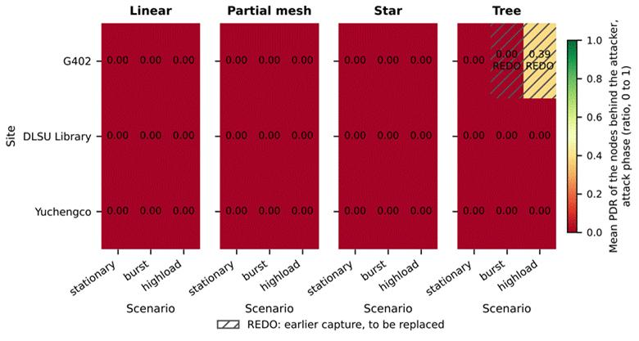

Figure 6.1 Mean PDR of the Victim Boards in the Attack Phase, for Each of the 36 Runs. REDO Marks the Two Earlier Captures to Be Replaced (provisional, 36 blackhole runs)
In Figure 6.1, each rectangle is one run. The panels are the topologies, the rows are the sites and the columns are the scenarios. The colour and the number give the mean PDR (ratio, 0 to 1) of the victim boards during the attack phase, where 0 means that no probe from them reached the root. Hatched cells marked REDO are the two earlier captures of tree at G402 that are to be replaced (Section 6.1).
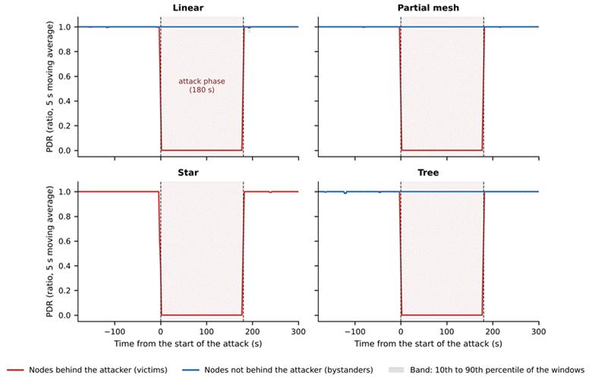

Figure 6.2 PDR of the Victim and Bystander Boards over the Run, by Topology (provisional, 36 blackhole runs)
In Figure 6.2, the horizontal axis is time in seconds from the start of the attack (0 s = start, 180 s = end, negative values = baseline), and the vertical axis is the PDR, the share of probes that reached the root (ratio, 0 to 1), as a 5 s moving average. The red line shows the victims and the blue line the bystanders, with a band from the 10th to the 90th percentile of the windows. The star has no bystanders. The shaded area is the attack phase.
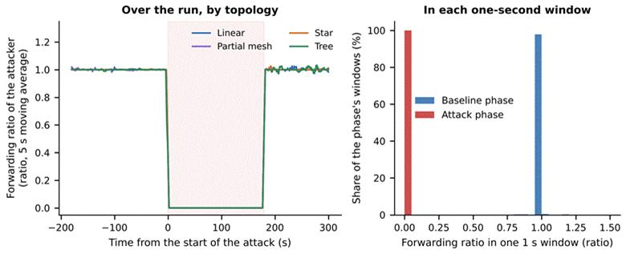

Figure 6.3 Forwarding Ratio of the Attacker over the Run (Left) and in Each One-Second Window (Right) (provisional, 36 blackhole runs)
In the left panel of Figure 6.3, the horizontal axis is time in seconds from the start of the attack, and the vertical axis is the forwarding ratio of the attacker (packets forwarded divided by packets received, 5 s moving average; 1 = everything forwarded, 0 = nothing forwarded), with one line for each topology. In the right panel, each bar counts the one-second windows of a phase whose forwarding ratio lies in that range, as a share of the windows of the phase (%). Values above 1.5 are drawn at 1.5.

6.2.2. Wormhole: Tunnel Replay
[PENDING: the wormhole evidence for all 36 wormhole runs: the setup check (the entry end deeper than the exit end, and the tunnel carrying the probes), the result of the 3-sigma test for the features that can be tested, the cells that could not be tested and why, and the hops skipped (Section 4.2.2). Nine wormhole runs are captured so far, all on the linear topology. The star, tree and partial-mesh cells are open.]

6.2.3. Single-Feature Audit
If one feature alone could separate attack windows from normal windows, the clustering would be unnecessary. Each feature is therefore tested alone. A single threshold on the feature is chosen, with sight of the labels, so that as many windows as possible are classified correctly (normal = 0, attack = 1), and the share classified correctly is the accuracy of the feature (Table 6.7). The accuracy is compared with the majority rate, the accuracy of a rule that always answers with the larger class (70.0% here, because normal windows are the larger class). An accuracy at the majority rate means that the feature carries no information about the label by itself, and an accuracy well above it means that the feature alone separates the windows. A high accuracy does not by itself show that the feature reveals the attack, because it can also come from an artefact of how the data were made. Arp et al. [80] list spurious correlation, where a feature that is an artefact of how the data were made decides the result, among the common pitfalls of machine learning in security, and this audit tests for it.
Table 6.7 Best Single-Threshold Accuracy of Each Feature (%) (provisional, 36 blackhole runs)
Feature | All child nodes (%) | Non-attacker nodes (%) | Victims only (%)
PDR | 87.1 | 87.1 | 99.7
LatencyHopRatio | 84.6 | 84.6 | 99.8
ForwardingRatio, ConsistencyScore | 80.4 | 71.7 | 69.8
IngressEgressDelta | 73.7 | 70.0 | 69.9
RetryRate | 73.1 | 70.0 | 69.9
RSSI_mean, RSSI_var, RSSI_stability, RSSI_Hop_Diff, ParentSwitchRate, HopChangeCount, HopStabilityDuration (highest of the seven) | 70.0 | 70.0 | 70.0
Run clock: raw board clock (window_start) / aligned (t_anchor_s) | 70.2 / 80.2 | 70.3 / 80.2 | 70.2 / 80.0
Majority rate | 70.0 | 70.0 | 69.9

Legend:
● Accuracy (%) = the share of windows labelled correctly by the best single threshold on the feature.
● Best single threshold = the cut-off value on one feature that labels the largest number of windows correctly.
● Majority rate = the accuracy of always answering with the larger class; a value at this rate means that the feature alone says nothing about the label.
● All child nodes = the 7 boards other than the root in each run (the attacker and the 6 non-attacker nodes); non-attacker nodes = the 6 boards that are neither the root nor the attacker; victims only = the non-attacker nodes behind the attacker.
● The run clock is the position of a window in the run; it is not a feature and is tested only to show how much the fixed phase schedule gives away.
● Raw board clock (window_start) = the time on the clock of each board, which starts when that board starts; aligned clock (t_anchor_s) = the position of a window in the run on a time axis that the boards of one run share.
● Highest of the seven = the best accuracy among the seven features named in the row.
● Features are defined in Table 6.4.
On the victims, one feature alone decides the label: PDR reaches 99.7% and LatencyHopRatio 99.8%, against a majority rate of 69.9%, and every other feature stays at the majority rate. This is expected for a blackhole, which drops every packet for the whole attack window, so a complete collapse of delivery is separable by construction. LatencyHopRatio decides the label mainly because it is undefined when nothing is delivered. Whether it is missing predicts the label with 99.0% accuracy on victims, and it is missing in 99.5% of their attack windows. For that reason it is kept out of the clustering. The aligned run clock alone gives 80.0%, about 10 percentage points above the majority rate, because every run follows the same phase schedule and one cut can remove the end of the run. It cannot isolate a window in the middle of the run, and it is kept out of the model inputs. The raw board clock gives 70.2%, because the boards start at different times. For all child nodes and for the non-attacker nodes the same two features reach only 87.1% and 84.6%, because the bystanders carry the attack label but behave as normal nodes (Section 6.4.3). Figure 6.4 shows the audit for the three groups of nodes.
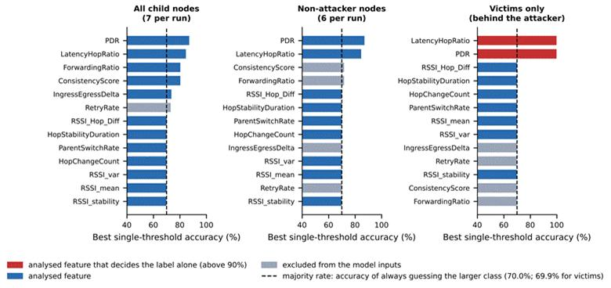

Figure 6.4 Best Single-Threshold Accuracy of Each Feature for Three Groups of Nodes (provisional, 36 blackhole runs)
In Figure 6.4, each bar is the accuracy (%) of the best single threshold on one feature in telling attack windows from normal windows. The dashed line is the majority rate, 70.0% (69.9% for the victims), which is the accuracy of always answering “normal”. A bar that ends at the dashed line means that the feature alone says nothing about the label, and a bar that goes beyond it means that the feature alone separates the windows to that degree. Red bars are analysed features that decide the label alone (above 90%), blue bars are the other analysed features, and grey bars are features excluded from the model inputs (Table 6.4). The left panel covers the 7 child nodes of each run (the attacker and the 6 non-attacker nodes), the middle panel the 6 non-attacker nodes (all boards except the root and the attacker), and the right panel the non-attacker nodes behind the attacker.

6.2.4. Predictions Tested and Not Observed
Table 3.4 predicted that victim nodes would retransmit more under the blackhole. The table rests on the cross-layer premise that a routing attack leaves correlated traces in the physical, MAC and network layers. This premise is taken from Al-Anzi [5] and Amouri et al. [8], on which the feature design of Section 4.3.1 is based, and from Srinivasan [19], who combines physical, MAC and network-layer knowledge against blackhole and wormhole attacks. These studies were used as the basis because they treat the three layers together, as this study does. The retransmission row itself is a hypothesis of this study and not a published result: a victim whose frames are not acknowledged would repeat them, and any rise was expected to be small because the attacker still acknowledges each frame (Section 3.3.1).
The prediction was not observed. The retry rate of the victims (the share of send attempts that failed, from application counters, deviation D-15) was 0.0015 in the baseline, 0.0006 in the attack and 0.0004 in the cooldown, so it did not rise during the attack. For the bystanders it was 0 in every phase. A rise would be expected if frames were left unacknowledged, but the attacker acknowledges every frame at the link layer (Section 3.3.1.2), so the sender never sees a failed delivery. Parent changes were also almost absent: the mean ParentSwitchRate (parent changes per second) of the victims was 0.00005 in the baseline and 0.00018 in the attack (Cohen’s d = 0.01). Table 3.4 is kept as it was written at proposal time, before any capture. The result is that an application-layer blackhole removes the delivery of the probes and leaves the link layer and the routing tree as they were.
[PENDING: the predictions tested for the wormhole (Table 3.5), once the wormhole runs are analysed.]

6.2.5. Cells That Could Not Be Fully Tested
Partial mesh at Yuchengco with stationary traffic could not be tested on PDR, because its baseline is unstable, and it is confirmed on the attacker’s forwarding ratio. Tree at G402 with highload fails the setup check. Four runs have no attack-phase values of the NeighbourForwardingRatio (Table 6.5), so that support check was not run for them. The wormhole cells are open (Section 6.2.2).

6.3. EDA Results
Exploratory analysis describes the structure of the data. It states no detection result. A difference described in this section is a difference between tables and pictures, and it is not a classifier. Table 6.8 compares the baseline and the attack phase. For each feature it gives the mean in each phase and Cohen’s d, for the victims and for the bystanders. Cohen’s d is the difference between the two phase means divided by the root mean square of the two standard deviations. It expresses the shift in units of spread: d = 1 means that the mean moved by one standard deviation, d = −16.6 means a shift of 16.6 standard deviations downwards, and a value near 0 means that the feature did not change. The sign gives the direction, and a negative value means a lower mean in the attack.
Table 6.8 Feature Means in the Baseline and the Attack Phase, and Cohen’s d (provisional, 36 blackhole runs)
Feature (unit) | Victims: mean in the baseline → in the attack | d (no unit) | Bystanders: mean in the baseline → in the attack | d (no unit)
PDR (ratio) | 0.998 → 0.005 | −16.55 | 0.996 → 1.000 | 0.09
RSSI_mean (dBm) | −74.7 → −74.9 | −0.02 | −72.4 → −72.6 | −0.04
RSSI_var (dBm²) | 0.421 → 0.307 | −0.07 | 0.323 → 0.191 | −0.09
RSSI_stability (s) | 0.894 → 0.896 | 0.05 | 0.895 → 0.898 | 0.07
RSSI_Hop_Diff (dB) | 3.21 → 3.35 | 0.04 | 3.99 → 4.02 | 0.00
ParentSwitchRate (parent changes per s), HopChangeCount (count per window) | 0.00005 → 0.00018 | 0.01 | 0.00000 → 0.00000 | no variation
HopStabilityDuration (s) | 1.000 → 1.000 | 0.01 | 0.999 → 0.999 | 0.01
IngressEgressDelta (packets per window) | 0.019 → 0.015 | −0.01 | 0.033 → 0.021 | −0.03
RetryRate (ratio) | 0.0015 → 0.0006 | −0.03 | 0.0000 → 0.0000 | no variation

Legend:
● The arrow separates the mean in the baseline phase from the mean in the attack phase.
● d = Cohen’s d, the shift of the mean in units of the root mean square of the two standard deviations (no unit).
● |d| = the size of d without its sign; by the convention of Cohen, 0.2 is small, 0.5 medium and 0.8 large.
● No variation = the feature has the same value in every window, so d is undefined.
● Victims and bystanders are defined at the start of the chapter.
● Baseline = the 300 s before the attack; attack = the phase in which the blackhole is on.
● What each feature measures is given in Table 6.4.
Table 6.13 (Section 6.5.2) sets these values beside published studies and gives, for each one, the protocol and the device that the published study used and the reason for any difference.
Only the delivery ratio moves, and only on the victims (d = −16.6). Every other feature changes by less than a tenth of a standard deviation, on the victims and on the bystanders alike. The PDR row for the victims includes the run that is not confirmed, so its attack mean is 0.005, and without it the mean is 0.000. Figure 6.5 shows the same comparison as box plots. In five of the ten panels at least 98% of the windows hold one value, so the box collapses to a single line in all four groups: IngressEgressDelta, RSSI_stability, ParentSwitchRate, HopChangeCount and HopStabilityDuration. The PDR box of the victims drops from 1 to 0, and no other panel shows a shift of that size. LatencyHopRatio is missing in 99.5% of the attack windows of the victims, so its box for that group describes a small remainder.
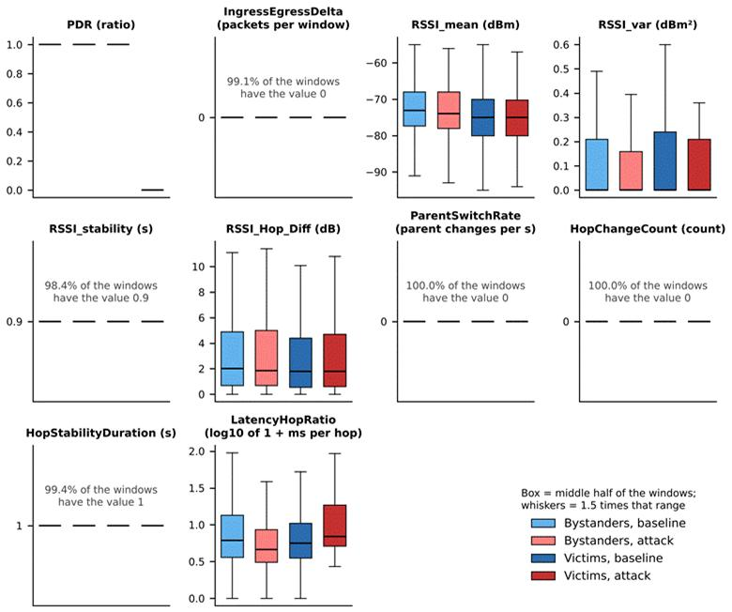

Figure 6.5 Feature Distributions by Phase for the Victims and the Bystanders (provisional, 36 blackhole runs)
Figure 6.5 has one panel for each feature, with its unit in the title. A box spans the middle half of the windows (25th to 75th percentile) with the median as a black line, and the whiskers reach up to 1.5 times that range; outliers are not drawn. Light blue and light red boxes are the bystanders in the baseline and in the attack, and dark blue and dark red boxes are the victims in the baseline and in the attack. A panel with a single line and a text label has the same value in nearly all windows. LatencyHopRatio is drawn as log10 of (1 + value) because its values are skewed.
Figure 6.6 gives the correlation between the features, calculated in two ways (Pearson and Spearman) for three sets of windows: all labelled non-attacker-node windows, the baseline windows and the attack windows. The 12 features that have a value in more than 30% of the non-attacker-node windows are included, on a random sample of up to 40,000 windows for each view. Only four pairs reach a correlation of 0.5 in size, and the same four appear in all three views: ParentSwitchRate with HopChangeCount (1.0), ForwardingRatio with ConsistencyScore (Spearman, −0.9), IngressEgressDelta with ConsistencyScore (Pearson, 0.7 to 0.8) and RSSI_var with RSSI_stability (Pearson, −0.8). The first three pairs are linked by their formulas and not by network behaviour (ConsistencyScore is |ForwardingRatio − 1|, and ParentSwitchRate and HopChangeCount count the same event), and RSSI_stability is derived from the RSSI variance. The correlation structure does not change between the baseline and the attack. Correlation is not treated as cause.
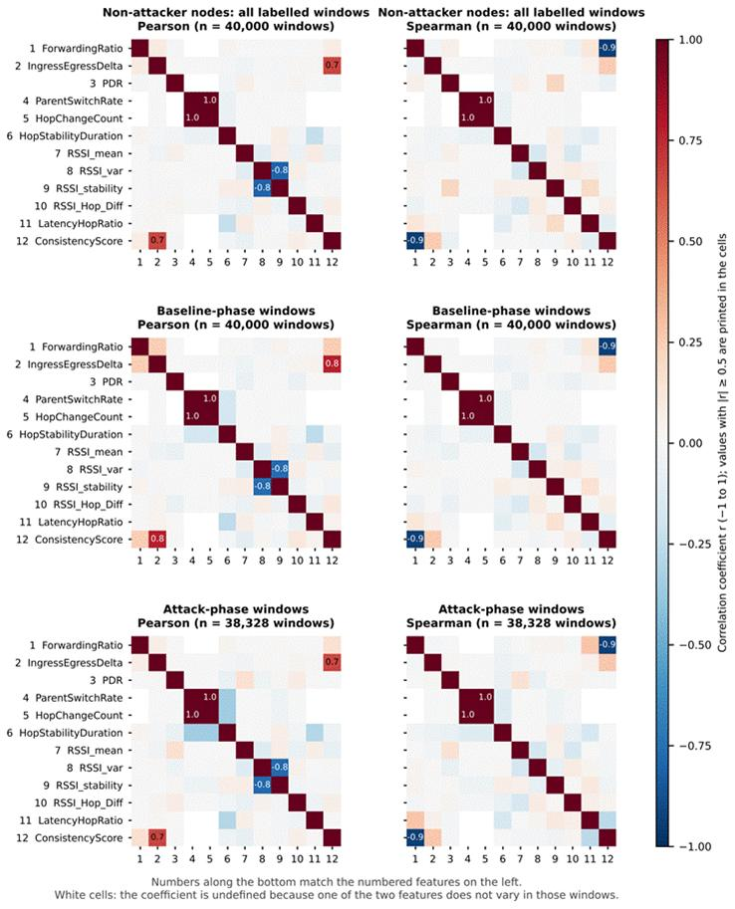

Figure 6.6 Pearson (Left) and Spearman (Right) Correlation between Features, for All Labelled Windows, the Baseline Windows and the Attack Windows (provisional, 36 blackhole runs)
In Figure 6.6, each cell gives the correlation coefficient r between two of the 12 features (−1 = they move in opposite directions, 0 = no relation, 1 = they move together; no unit). The numbers along the bottom match the numbered features on the left. Pearson measures straight-line relations and Spearman measures rank relations. Only values with |r| ≥ 0.5 are printed, and white cells are undefined, because one of the two features does not vary in those windows.
The 8 benign runs give a stand-alone view of normal behaviour. In the seven benign runs that could be tested, the PDR of the child boards was between 0.999 and 1.000 in both the baseline and the cooldown, every relay forwarded at least 90% of the probes it received, and neither the blackhole signature nor the wormhole signature moved (Section 6.2.6). The normal phases of the attack runs agree with this: the victims had a baseline PDR of 0.998 and the bystanders of 0.996 (Table 6.12). [PENDING: Table 4.22 (baseline windows by site), the pooled comparison of the benign runs with the baselines of the attack runs, and the per-cell figures of the wormhole runs, from the final pooled analysis.]

6.4. Clustering Results

6.4.1. Setup
The clustering follows the procedure of Chapter 4. A cluster is a set of windows that an algorithm puts together because their feature values are close, without seeing the label. Five algorithms (K-Means, Ward hierarchical clustering, a Gaussian mixture model (GMM), DBSCAN and spectral clustering) are run on standardised features, with k, the number of clusters, from 2 to 8 and three seeds (42, 7 and 123). Each seed draws a new sample of 6,000 windows from the non-attacker-node windows that have every feature of the set (126,741 for FULL and REDUCED, 127,666 without PDR), and restarts the algorithm. DBSCAN takes min_samples between D + 1 and 2D, where D is the number of features, and eps, the neighbourhood radius, at the knee of the k-distance graph (Figure 6.7). Cluster purity and the adjusted Rand index (ARI) are computed afterwards against the label (baseline and cooldown = 0, attack = 1) and are never used to form a cluster. All results below are means over the three seeds, with k = 2 for the four methods that need k.
Table 6.9 Feature Sets Used for Clustering (provisional, 36 blackhole runs)
Feature set | Features | Count | Purpose
FULL | PDR, ParentSwitchRate, HopChangeCount, HopStabilityDuration, RSSI_mean, RSSI_var, RSSI_stability, RSSI_Hop_Diff | 8 | All features eligible for clustering (Table 6.4); the start of both filters.
REDUCED | PDR, RSSI_mean, RSSI_var, RSSI_Hop_Diff | 4 | FULL after the low-variance and correlation filters (Section 4.2.4.6).
REDUCED without PDR | RSSI_mean, RSSI_var, RSSI_Hop_Diff | 3 | Control: REDUCED without the delivery ratio.

Legend:
● A feature set is the group of features given to the clustering algorithms.
● The names FULL, REDUCED and Without PDR are used in Table 6.10 and in the figures of this section.
● The FULL pool is the 126,741 non-attacker-node windows that have every FULL feature, and the percentages are the share of that pool that holds the most common value of the feature.
● Low-variance filter = drops a feature when more than 90% of the windows of the pool have the same value.
● Correlation filter = drops a feature when |r| > 0.85 with another kept feature; r = the correlation coefficient between two features (−1 to 1).
● PDR = packet delivery ratio, the share of a node’s probes that reached the root (ratio, 0 to 1).
● RSSI = received signal strength indicator; dBm = decibel-milliwatts; dB = decibels.
● Clustering = the grouping of windows by an algorithm that does not see the label.
● Control = a set used to test whether anything other than the delivery ratio separates the windows.
Three feature sets are compared (Table 6.9). FULL contains the 8 features that may enter the clustering of non-attacker nodes (Table 6.4) and is the starting point of the two filters of Section 4.2.4.6. REDUCED is FULL after these filters. The low-variance filter drops a feature when more than 90% of the windows of the FULL pool have the same value, and it removed ParentSwitchRate (100%), HopChangeCount (100%), HopStabilityDuration (99.4%) and RSSI_stability (98.4%). The correlation filter drops a feature when |r| > 0.85 with another kept feature, and it removed none, because the largest |r| among the four kept features is 0.11. The third set, REDUCED without PDR, serves as a control: it removes the delivery ratio from REDUCED, to show whether anything other than PDR separates the windows.
The dataset defines 16 features, but only 8 can enter the clustering of non-attacker nodes (Table 6.4). Two populations are clustered: all non-attacker nodes, and victims only. The first includes windows from bystanders that carry the attack label (Section 6.1), and the second does not.
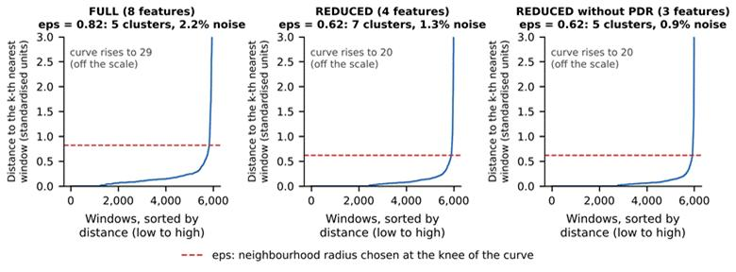

Figure 6.7 DBSCAN k-Distance Graphs for the Three Feature Sets (All Non-attacker Nodes, Seed 42) (provisional, 36 blackhole runs)
In Figure 6.7, each curve orders the 6,000 sampled windows (horizontal axis) by their distance to the k-th nearest other window, where k is the min_samples value of DBSCAN (vertical axis, standardised units). The dashed line is eps, the neighbourhood radius used by DBSCAN, set at the knee where the curve turns upward. A window with fewer than min_samples neighbours within eps is treated as noise. The vertical axis is cut at 3 and the curves rise to 29, 20 and 20.

6.4.2. Quality and Agreement with the Label
Table 6.10 gives the quality metrics and the agreement with the label for every algorithm and feature set. A purity of 0.693 is the majority rate of the sample, so it means no separation.
Table 6.10 Clustering Quality and Agreement with the Label, Means over Seeds 42, 7 and 123 (provisional, 36 blackhole runs)
Feature set | Algorithm | Silhouette (−1 to 1) | Davies–Bouldin (0 and up) | Purity (0 to 1) | ARI, all non-attacker nodes (−1 to 1) | ARI, victims only (−1 to 1)
REDUCED | K-Means | 0.482 | 0.918 | 0.869 | 0.515 | 0.991
REDUCED | Ward | 0.472 | 0.893 | 0.865 | 0.503 | 0.881
REDUCED | GMM | 0.443 | 1.383 | 0.808 | 0.336 | 0.657
REDUCED | DBSCAN (5 to 7 clusters, 1.3% noise) | 0.511 | 0.463 | 0.865 | 0.488 | 0.926
REDUCED | Spectral | 0.175 | 0.806 | 0.693 | −0.000 | 0.001
FULL | K-Means | 0.847 | 0.651 | 0.693 | −0.002 | −0.003
FULL | Ward | 0.853 | 0.570 | 0.693 | −0.002 | −0.004
FULL | GMM | 0.401 | 1.615 | 0.811 | 0.373 | 0.658
FULL | DBSCAN (5 clusters, 2.3% noise) | 0.524 | 0.430 | 0.864 | 0.475 | 0.925
FULL | Spectral | 0.281 | 0.927 | 0.693 | 0.002 | 0.001
Without PDR | K-Means | 0.321 | 1.243 | 0.693 | −0.000 | 0.002
Without PDR | Ward | 0.654 | 0.904 | 0.693 | 0.000 | 0.002
Without PDR | GMM | 0.434 | 2.012 | 0.693 | −0.009 | −0.012
Without PDR | DBSCAN (4 to 5 clusters, 1.1% noise) | 0.678 | 0.273 | 0.693 | −0.002 | −0.005
Without PDR | Spectral | −0.321 | 1.758 | 0.693 | 0.001 | 0.000

Legend:
● Feature set: REDUCED = 4 features (PDR, RSSI_mean, RSSI_var, RSSI_Hop_Diff); FULL = 8 features; Without PDR = the 3 REDUCED features other than PDR (Table 6.9).
● K-Means = groups windows around k centres, each window going to the nearest centre; Ward = hierarchical clustering that merges the two clusters whose union adds the least spread; GMM = Gaussian mixture model, which assumes that the windows come from k bell-shaped groups; DBSCAN = groups windows that lie in dense regions and leaves isolated windows as noise; Spectral = groups windows using the eigenvectors of a graph of their similarities.
● k = the number of clusters.
● Seeds 42, 7 and 123 = the three random starting values; each draws a new sample of 6,000 windows and restarts the algorithm.
● Silhouette = how well each window fits its own cluster compared with the nearest other cluster (higher is better).
● Davies–Bouldin = the average similarity of each cluster to its most similar cluster (lower is better).
● Purity = the share of windows that carry the majority label of their cluster.
● ARI (adjusted Rand index) = agreement between the clusters and the labels: 1 = exact match, 0 = no better than chance, negative = worse than chance.
● For DBSCAN, which chooses its own number of clusters, the number found and the share of windows left as noise are given in brackets.
● The silhouette score and the Davies–Bouldin index describe the shape of the clusters, and purity and ARI describe their agreement with the label.
● All non-attacker nodes and victims only are the two populations that are clustered (Section 6.4.1).
With the delivery ratio among the features, clustering separates the windows in which the attack is felt. K-Means with k = 2 on the REDUCED set reaches an ARI of 0.515 on all non-attacker nodes and 0.991 on victims alone. Ward and DBSCAN agree (0.503 and 0.488 on all non-attacker nodes, 0.881 and 0.926 on victims alone). Without the delivery ratio, no algorithm finds the attack. The ARI stays between −0.015 and 0.007 for every algorithm and every k from 2 to 8, and the t-SNE picture shows no structure (Figure 6.13). The blackhole does not show in the signal strength features. Figure 6.8 gives the ARI against k, Figure 6.9 the silhouette score and Figure 6.10 the Davies–Bouldin index.
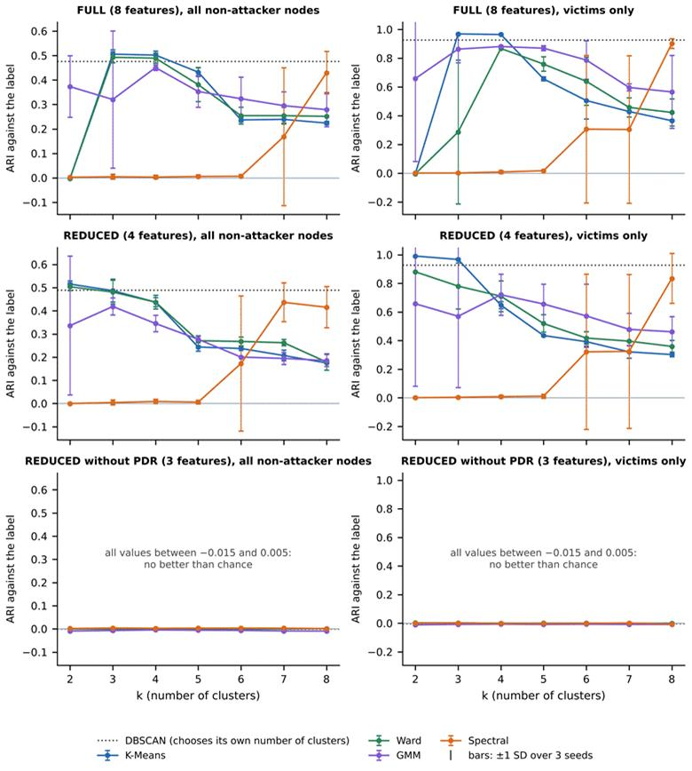

Figure 6.8 Adjusted Rand Index against the Number of Clusters, by Feature Set and Population (Mean and Spread over Three Seeds) (provisional, 36 blackhole runs)
In Figure 6.8, the horizontal axis is k, the number of clusters, and the vertical axis is the ARI against the label (1 = the clusters match the labels exactly, 0 = no better than chance). The rows are the feature sets, the left column is all non-attacker nodes and the right column is victims only. Each coloured line is one algorithm, and its bars show ±1 standard deviation over the three seeds (cut at 1). The dotted line is DBSCAN, which chooses its own number of clusters. In the bottom row, all values lie between −0.015 and 0.005 and are drawn on the same scale as the row above.
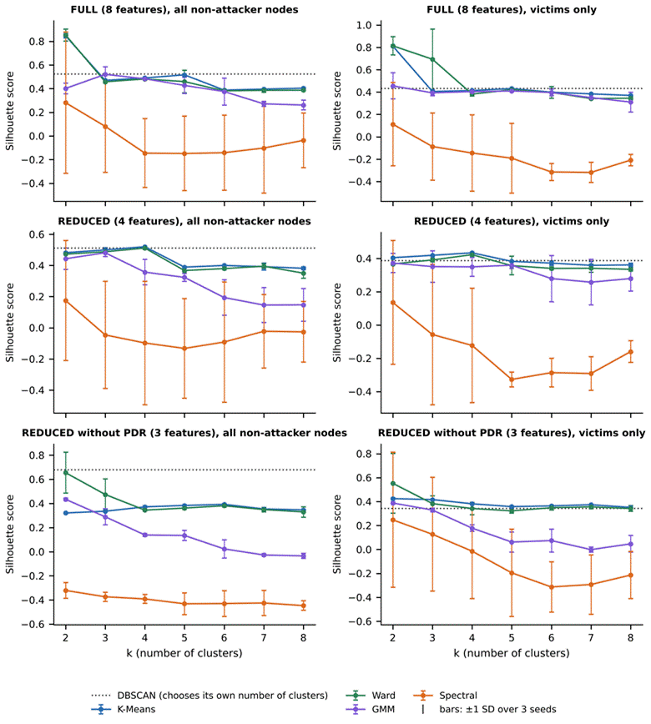

Figure 6.9 Silhouette Score against the Number of Clusters, by Feature Set and Population (provisional, 36 blackhole runs)
Figure 6.9 has the same layout as Figure 6.8. The vertical axis is the silhouette score (−1 to 1, no unit), and a higher value means that the windows lie closer to their own cluster than to the nearest other cluster. The silhouette score describes the shape of the clusters and not their agreement with the label.
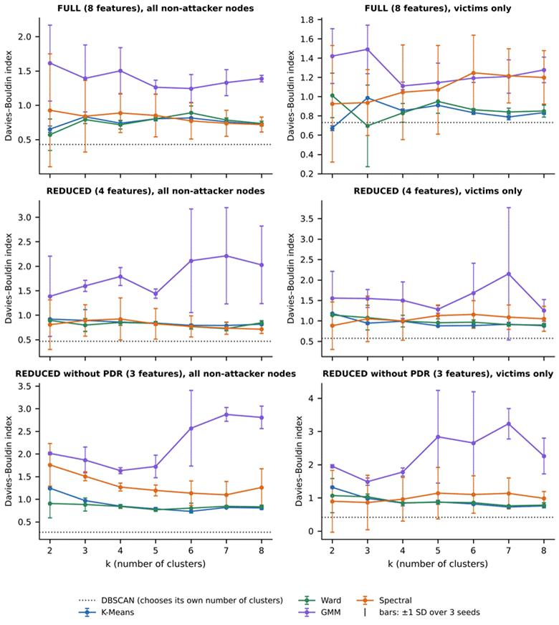

Figure 6.10 Davies–Bouldin Index against the Number of Clusters, by Feature Set and Population (provisional, 36 blackhole runs)
Figure 6.10 has the same layout as Figure 6.8. The vertical axis is the Davies–Bouldin index (0 and above, no unit), and a lower value means that the clusters are more compact and further apart.

6.4.3. What Limits the Agreement
The ceiling on all non-attacker nodes is an ARI of 0.528, not 1. A bystander carries the attack label in the attack window but behaves like a normal node, and 42% of the attack-labelled non-attacker-node windows come from bystanders. No method that reads only the features of a window can group them with the attack. A perfect separation of the windows in which the attack is felt scores 0.528 on all non-attacker nodes, and K-Means on the REDUCED set scores 0.515 (sd 0.014 over the seeds). On victims alone the same run scores 0.991. The victims-only figure is therefore reported next to the all-nodes figure.
The silhouette score alone picks the wrong k on the FULL set. K-Means and Ward score highest at k = 2 (0.85 for both), but in K-Means this split cuts off about 30 of the 6,000 windows, which have an extreme RSSI variance (a mean of about 14 against 0.2 for the rest) and a low RSSI stability, and its ARI is 0. K-Means with k = 3 recovers the attack (ARI 0.505 on all non-attacker nodes and 0.970 on victims). The choice of k therefore has to use the elbow, the silhouette peaks and interpretability together, as Chapter 4 sets out.
GMM is seed-sensitive. On the REDUCED set at k = 2 it matched K-Means on two seeds (ARI 0.517 and 0.500) and fell to −0.010 on the third, so its mean of 0.336 (sd 0.299 over the seeds) is not a stable result. Spectral clustering does not find the attack on any feature set for k = 2 to 5, where its mean ARI is at most 0.009. At larger k it reaches 0.17 to 0.44 on the FULL and REDUCED sets, with a standard deviation of up to 0.29 over the seeds, so it is reported and not relied on.
Figure 6.11 shows what each K-Means cluster contains at k = 3. With the delivery ratio among the features (FULL and REDUCED), one cluster of about 1,060 windows is almost entirely attack windows of the victims. A second cluster holds the rest, and a third, of 25 to 30 windows, holds the extreme RSSI variance. Without the delivery ratio, every cluster is a mixture of the four kinds of window. Table 6.11 gives the profile of the two K-Means clusters at k = 2 on the REDUCED set: Cluster 1 (18% of the windows) is 99.2% attack-phase windows with a mean PDR of 0.000, and Cluster 0 has a mean PDR of 1.000 and holds the attack windows of the bystanders.
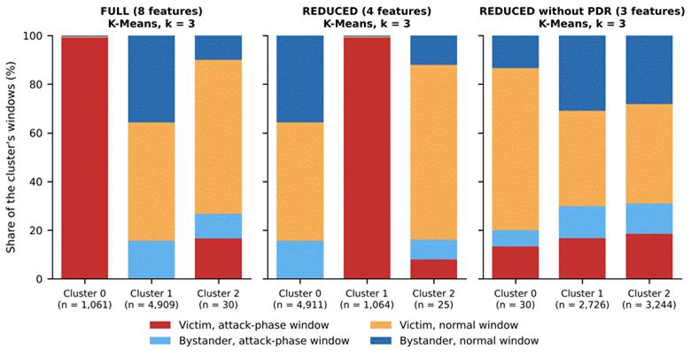

Figure 6.11 Composition of Each K-Means Cluster at k = 3, by Feature Set (provisional, 36 blackhole runs)
In Figure 6.11, each bar is one cluster, with the number of windows in it (n) under its name, and its height is split into the share (%) of four kinds of window. Red = victim windows in the attack phase, light blue = bystander windows in the attack phase, orange = victim normal windows and dark blue = bystander normal windows. Normal means baseline or cooldown. A bar that is entirely red holds only attack windows of victims.
Table 6.11 K-Means Clusters at k = 2 on the REDUCED Set (All Non-attacker Nodes, Seed 42) (provisional, 36 blackhole runs)
Measure (unit) | Cluster 0 | Cluster 1
Windows (count) | 4,934 | 1,066
Attack-phase windows (%) | 15.6 | 99.2
Baseline windows (%) | 60.3 | 0.8
Cooldown windows (%) | 24.1 | 0.0
Windows from victims (%) | 48.8 | 99.5
Mean PDR (ratio) | 1.000 | 0.000
Mean RSSI_mean (dBm) | −73.5 | −74.7
Mean RSSI_var (dBm²) | 0.295 | 0.249
Mean RSSI_Hop_Diff (dB) | 3.60 | 3.19

Legend:
● The percentages are shares of the windows in the cluster.
● The three phase rows (attack, baseline and cooldown) add up to 100% in each cluster.
● Mean values are the mean of each feature over the windows of the cluster.
● Cluster numbers are the labels given by the algorithm and carry no meaning.
● K-Means = groups windows around k centres; k = 2 is the number of clusters; REDUCED = the feature set of Table 6.9.
● Seed 42 = the random starting value that fixes the sample of 6,000 windows and the start of the algorithm.
● Windows from victims = the share of the windows of the cluster that come from victim boards.
● PDR = packet delivery ratio, the share of a node’s probes that reached the root (ratio, 0 to 1).
● RSSI = received signal strength indicator; dBm = decibel-milliwatts; dB = decibels.

6.4.4. Robustness across Sites, Topologies and Labelling
The result holds in every subgroup (Table 6.12). K-Means with k = 2 on the REDUCED set stays within 0.03 of the best possible ARI inside each site and each topology, and without the delivery ratio it stays at 0 inside each of them. The best possible figure is the ARI of one particular partition, so a method can edge past it, as it does in the linear topology. Dropping the cooldown windows from the normal label keeps the same pattern: with the delivery ratio, K-Means purity is 0.839 against a majority rate of 0.627, and without it purity equals the majority rate.
Table 6.12 K-Means (k = 2) ARI inside Each Site and Topology, All Non-attacker Nodes (provisional, 36 blackhole runs)
Subgroup | Best possible ARI (−1 to 1) | REDUCED: K-Means ARI (−1 to 1) | REDUCED without PDR: K-Means ARI (−1 to 1)
Site G402 | 0.567 | 0.547 | 0.005
Site DLSU Library | 0.574 | 0.574 | 0.002
Site Yuchengco | 0.447 | 0.426 | −0.004
Linear | 0.560 | 0.565 | −0.001
Star | 1.000 | 0.999 | −0.003
Tree | 0.319 | 0.311 | 0.002
Partial mesh | 0.287 | 0.277 | −0.001

Legend:
● ARI = adjusted Rand index, the agreement between the clusters and the labels (1 = exact match, 0 = no better than chance).
● Best possible ARI = the ARI of the partition that puts exactly the windows in which the attack is felt (victim windows in the attack phase) in one group and every other window in the other; it is the agreement that a method reading only the features of a window would reach if it found exactly those windows, and it is below 1 where there are bystanders, which carry the attack label but behave as normal nodes (it is 1.000 in the star, which has none). Because it is the ARI of one particular partition, a method can edge past it, as in the linear topology.
● REDUCED and REDUCED without PDR are the feature sets of Table 6.9.
● K-Means (k = 2) = groups windows around two centres, each window going to the nearest.
● Each row clusters only the windows of that site or topology.
● Site = where the runs were made (G402, the DLSU Library or Yuchengco); topology = the shape in which the boards are linked to the root.
The seed spread of Section 6.4.2 measures only how much the result moves when the sample of 6,000 windows and the starting points of the algorithm change. It does not measure how much it moves from run to run, and the 213,148 windows come from only 36 runs. A run-level check was therefore added. One K-Means model (k = 2, REDUCED set, seed 42) was fitted on a sample of 6,000 windows and applied to every window of the non-attacker nodes. Its ARI over all windows is 0.519. Resampling the 36 runs with replacement (300 times) gives a 95% interval of 0.42 to 0.63, which is much wider than the seed spread (sd 0.014) and still far from 0. Inside each run, the model comes within 0.05 of the best possible ARI of that run in 34 of the 36 runs. The two exceptions are the two runs already marked in Table 6.3: partial mesh at Yuchengco with stationary traffic (ARI 0.07 against a best possible 0.14) and tree at G402 with highload (0.14 against 0.24). Without the delivery ratio, the same check gives an ARI between −0.01 and 0.03 in every run, and no run comes within 0.05 of its best possible value.

6.4.5. Projections
Figure 6.12 projects the standardised FULL features of a sample of 6,000 non-attacker-node windows to two dimensions with PCA and t-SNE, so that each window becomes a point on a plane. In both projections the attack windows of the victims form their own group, a visible concentration of points away from the rest, and the attack windows of the bystanders lie among the normal windows. Figure 6.13 repeats the projection after the delivery ratio is removed: the four kinds of window overlap and no structure is visible. The axes of t-SNE have no units, and only nearness is read from them.
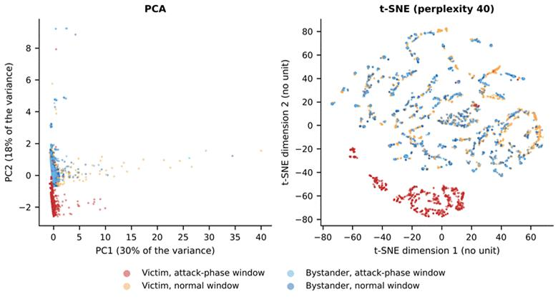

Figure 6.12 PCA and t-SNE Projections of the FULL Feature Set (provisional, 36 blackhole runs)
In Figure 6.12, each point is one window (a sample of 6,000), coloured by its kind (red = victim attack-phase, orange = victim normal, light blue = bystander attack-phase, dark blue = bystander normal). The eight features of a window are reduced to two numbers so that the window can be drawn on a plane. PCA (left) uses the two directions that hold the most variance: PC1 holds 30% of the variance and PC2 holds 18% (the axes are in standardised feature units). t-SNE (right) places windows with similar features close together; its axes have no unit, and only the distance between points means anything. “Group” here means points that lie close together in the picture. A cluster, by contrast, is the result of an algorithm (Section 6.4.1).
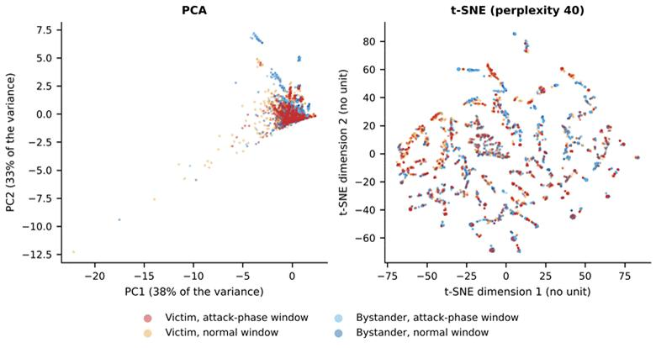

Figure 6.13 PCA and t-SNE Projections with the Delivery Ratio Removed (provisional, 36 blackhole runs)
Figure 6.13 is built in the same way as Figure 6.12, but only RSSI_mean, RSSI_var and RSSI_Hop_Diff are used. In PCA, PC1 holds 38% of the variance and PC2 holds 33%. The colours are the same as in the previous figure. The four colours lie on top of one another in both pictures, which means that these three features do not separate the attack windows.
[INSERT HERE: Block C1 (new Section 6.4.6, Table 6.17 and Figure 6.16) from the tab ‘Claude – new sections’.]

6.5. Discussion
[PENDING: this discussion reads the blackhole results only. Extend it with the wormhole and benign results, and read every sentence again against the final tables before the chapter is submitted.]

6.5.1. In relations of the Research Objectives
The first objective (Section 1.3) was to establish an ESP32 mesh testbed that generates multi-hop traffic under normal operation and controlled attack. The 36 blackhole cells were run on the 8-board testbed at three sites and in four topologies, and in every run the attacker did what the design says: between 0.0% and 0.7% of what it received was forwarded during the attack, against 100% before (Table 6.5).
The second objective was to collect and structure cross-layer features into a labelled and documented dataset. The dataset holds 213,148 labelled one-second windows with the cross-layer features of Chapter 4. Of the 16 features, 8 can enter the clustering of non-attacker nodes, and only one of them, PDR, responds to the blackhole (Tables 6.4 and 6.8). The other features are recorded and documented, and they do not change when a blackhole is placed in the mesh.
The third objective was to assess, through exploratory analysis and unsupervised methods, whether normal and attack-induced behaviours are separable. For the blackhole, the windows in which the attack is felt separate from the normal windows when PDR is a feature (ARI 0.515 on all non-attacker nodes against a ceiling of 0.528, and 0.991 on victims alone), and they do not separate without it (ARI between −0.015 and 0.007). The separation is therefore carried by one feature. Because PDR is also what the verifier checks to confirm the attack (Table 6.5), this agreement shows that the clustering finds the effect that the verifier measured. It is not independent evidence that the cross-layer features detect the blackhole, and the finding that they do not is the more informative one. Chapter 4 expected that the clusters would reflect a confluence of cross-layer evidence, and for the blackhole this is not what the data show.

6.5.2. In relations of the Published Studies
Airehrour et al. [70] report packet loss of 60% to 75% under a blackhole attack with the standard protocol (RPL with the MRHOF objective function). In the collected data the victims lost every probe (PDR 0.000 in the attack phase of all 35 valid runs), which is above the published range and in the same direction. The setups differ (Table 6.13), and in this study the loss is measured on the victims, whose every probe is dropped by the attacker, so the comparison covers direction and not equal values. The same authors report 16 to 246 rank changes per mote. Almost no parent changes were observed here (Section 6.2.4), and the difference is explained by the attack design, because suppressing forwarding does not alter routing. Khan et al. [22] report delivery above 97% in a healthy ESP-MESH network on the same platform, except for one outdoor node. The baseline PDR in the collected runs is 0.998 for the victims and 0.996 for the bystanders, per one-second window, which is consistent with that benchmark.
Table 6.13 Measured Values Compared with Published Studies (provisional, 36 blackhole runs)
Feature | This study | Published value | Study, protocol and device | Reason for the difference
PDR in the baseline (ratio) | 0.998 (victims), 0.996 (bystanders) | More than 0.97 for every node except one outdoor node [22] | Khan et al. [22]: ESP-MESH on ESP32 boards, 7 sensor nodes and a root. | Same protocol and device family; the counting differs, so the two are not claimed equal.
PDR in the attack (ratio) | 0.000 in the 35 valid runs (0.005 with the run that is not confirmed) | Packet loss of 60% to 75%, which is a delivery of 25% to 40% [70] | Airehrour et al. [70]: RPL (MRHOF), 14 AS-XM1000 (Telos-B) motes in a laboratory. | Loss there depends on route choice; here the attacker is on the path.
ParentSwitchRate (parent changes per s) | 0.00005 → 0.00018 (victims, d = 0.01) | 16 to 246 rank changes per mote [70] | Airehrour et al. [70]: as above. | Different metric and mechanism; routing is untouched here (D-20).
RetryRate (ratio) | 0.0015 → 0.0006 (victims) | No published value for this attack in the studies compared here | Not applicable. | ESP-IDF gives no MAC retry count (D-15).
RSSI_mean, RSSI_var, RSSI_Hop_Diff and the other features of Table 6.8 | |d| below 0.1 (Table 6.8) | No comparable value in [70], [22], [71] or [72] | Not applicable. | No published value to compare with.

Legend:
● This study: 8 ESP32 boards running ESP-WIFI-MESH, with a blackhole emulated at the application layer (D-20), measured in one-second windows.
● Published value = the value reported by the cited study.
● d = Cohen’s d (Section 6.3).
● Victims and bystanders are defined at the start of the chapter.
● MRHOF = minimum rank with hysteresis objective function of RPL; RPL = routing protocol for low-power and lossy networks.
● Mote = a small wireless sensor node; rank = the value that an RPL mote computes for its distance from the sink, so a rank change means that the mote moved in the routing tree; sink = the node that collects the data.
● Packet loss = the share of packets that do not arrive; loss = 1 − delivery.
● UDP = user datagram protocol, a transport protocol that sends packets without a connection and without confirming delivery.
● PDR = packet delivery ratio, the share of a node’s probes that reached the root (ratio, 0 to 1).
Table 6.13 sets each measured value beside a published one. For the baseline PDR, Khan et al. [22] used ESP-MESH on ESP32 boards, with 7 sensor nodes and a root, and one 64-byte package per node every minute (open-area test) or every 2 min (campus test) for 5 days. The protocol and the device family are the same, and the values agree in size. The published figure counts one package every 1 to 2 min over five days, whereas this study counts probes in one-second windows over a 300 s baseline, so the two are not claimed to be equal.
For the PDR in the attack and for the parent changes, the source is Airehrour et al. [70], who used RPL with the MRHOF objective function in a research laboratory of about 30 m by 30 m, with a testbed described as 14 AS-XM1000 (Telos-B) motes running InstantContiki 3.0 (1 UDP sink, 12 UDP senders and 2 blackhole motes are listed). In [70] the loss depends on which motes select a blackhole mote as parent through the routing protocol (their Figures 5 and 6), and loss is counted between a sender and the sink. Here the attacker is placed on the path (D-20, the attack is emulated at the application layer) and every probe of a victim passes it, so all are lost. The metric for parent changes also differs (rank changes of RPL motes against parent changes of mesh boards per second), and so does the mechanism. In [70] the attack acts inside the routing protocol and ranks change, whereas here forwarding is suppressed without touching routing (D-20), so the tree stays as it was.
For RetryRate, the studies compared here give no published value for this attack. ESP-IDF returns no MAC retry count, so RetryRate is an application counter (deviation D-15) and cannot be compared with MAC-layer retransmission counts. Finally, RSSI_mean, RSSI_var, RSSI_Hop_Diff and the other features of Table 6.8 belong to the cross-layer feature set of this study (Section 4.2.4), so that there is no comparable published value in [70], [22], [71] or [72] to set them against.
[PENDING: the comparison for the wormhole with Zhukabayeva et al. [71] and Ramírez Gómez et al. [72], and the update of Table 4.23 and Tables 4.26 to 4.30 from the final results. Table 4.23 and Section 4.2.7.6 say that Khan et al. [22] report delivery above 97%, but their campus result excludes node H, so the sentence has to add that exception.]

6.5.3. What an Emulation Can and Cannot Show
The blackhole acts on the application-layer probes. The probes of the nodes behind the attacker are received by the attacker and not forwarded, but every frame is still acknowledged at the link layer, so signal strength, retries and parent choices are not touched (D-20, application-layer emulation). The dataset therefore records the effect of forwarding suppression on delivery. It does not record how a node attracts traffic to itself, which is the route-attraction stage of a classical blackhole (Section 6.6). This is why the delivery ratio carries the whole result, and it is a property of the emulation as much as of the attack.

6.5.4. Limits
Each combination of topology, site and scenario was run only once, so the three sites serve as the repeats, and site differences cannot be separated from run-to-run noise. The seeds of Section 6.4 change the sample and the starting points of the algorithms and not the data.
The windows are also not independent. The 213,148 windows come from 36 runs, and the windows of one board in one phase are not independent draws, so the number of independent observations is closer to the number of runs than to the number of windows. This is why the run-level interval of Section 6.4.4 is wider than the seed spread of Section 6.4.2. The effect sizes of Table 6.8 treat windows as independent and are therefore read as sizes of a shift and not as significance tests.
The partial-mesh runs behave as plain trees. In all 9 partial-mesh blackhole runs every node was seen under a single parent during the labelled phases, and parent changes occurred only during mesh formation (Section 1.4.1).
The label imposes a further limit. It marks every window of every node in the attack phase as attack, including the windows of bystanders, which caps the ARI at 0.528 on all non-attacker nodes.
The burst and highload scenarios add controlled variation in traffic, so that traffic volume alone cannot indicate an attack, but they are not a model of campus traffic.
In the pooled tables of Sections 6.1 to 6.4.5, normal means baseline and cooldown. The 8 benign runs were checked one by one (Section 6.2.6), and they enter the final clustering as normal windows (Section 6.4.6), where they fell in the same cluster as the normal phases of the attack runs. The benign runs are fewer than planned. The final plan has 8 benign runs instead of 12, and the tree and the partial mesh have one benign run each, both at G402, so the stand-alone control is thin for those two topologies, and within one topology the benign scenario and the site are confounded (D-35). The benign runs also give a first answer on false alarms: in none of the seven tested benign runs, two of them with highload traffic and one with a burst, did the blackhole or the wormhole signature move, so the scenarios alone did not imitate an attack. With seven runs, however, the false-alarm rate is only roughly bounded.
[PENDING: add [80] Arp, D., Quiring, E., Pendlebury, F., Warnecke, A., Pierazzi, F., Wressnegger, C., Cavallaro, L., & Rieck, K. (2022). Dos and don’ts of machine learning in computer security. In 31st USENIX Security Symposium (USENIX Security 22). USENIX Association. to Appendix A, because Section 6.2.3 cites it.]

6.6. Future Work
The two attacks in this study are application-layer emulations, so the route-attraction stage of a blackhole and the false-neighbour effect of a wormhole are not in the dataset. A later study could add them, either on a routing protocol whose route handling can be modified, or on ESP-WIFI-MESH itself by building the attack below the application layer, for example by forging the mesh’s own management frames, which needs radio-level tools and was outside this study. A dataset made that way could be set beside this one to show what the route-attraction stage adds to the cross-layer signature.

6.7. Conclusion
[PENDING: state the contribution of the study against the objectives of Section 1.3, using only results that appear in the final tables. Write it after collection ends. The blackhole findings in this draft are interim, and the wormhole and benign results are not in yet.]

